
1503 Lyndon B. Johnson Fwy. Dallas, TX 75234

December 15, 2005

Ms. Cara Packer
Senior Purchasing Manager – Global IT Services
JCPenney
6501 Legacy Drive
Plano, TX 75024
Dear Ms. Packer:
We wanted to thank you and the JCPenney team for considering IBM as a partner in your future Enterprise Information Architecture project focused upon delivering a financial reporting data warehouse. Based upon your RFI, our existing work on the Active Data Warehouse (ADW) and our current relationship with JCPenney, we have created a response that demonstrates our capabilities and experience within the areas you have outlined. We understand the importance of this initiative to JCPenney and likewise view this initiative as extremely important to IBM.
Thus, we have provided you with a comprehensive response that will differentiate the value we bring to JCPenney. Some of those differentiators include the following:
- A skilled team with previous experience delivering business intelligence, data warehousing, and finance process improvement engagements
- Leveraging our previous business intelligence and data integration work at JCPenney
- A proven and flexible approach and methodology
- Broad and deep experience with the architecture and toolsets that JCPenney is currently using and that IBM can provide
- A hypothesis based approach using a proposed suite of tools that will allow us to immediately begin design and development and that has been proven in multiple retail environments
We believe that our knowledge of the current environment, the flexibility to adapt our resources and methodology, along with IBM’s unwavering partnership will be key to meeting the JCPenney timeline.
Sincerely,
Tony Bevacqua Todd Bixby Spencer Mallder
Tony Bevacqua Todd Bixby Spencer Mallder Associate Partner, Financial Mgt. Partner, Retail BI Partner, Retail

IBM Response to JCPenney RFI
JCPenney Procurement, L.P.
Request For Information
for
Consulting Services in support of JCPenney
Development of an Enterprise Information Architecture
Release Date: December 1, 2005
Due Date: December 15, 2005
5:00 PM CST

Presented to JCPenney
By IBM Business Consulting Services
1503 Lyndon B Johnson Freeway
Dallas, TX 75234
12/15/05

Disclosure Statement
The information in this proposal shall not be disclosed outside the JCPenney organization and shall not be duplicated, used or disclosed in whole or in part for the purpose other than to evaluate the proposal, provided that if a contract is awarded to IBM as a result of or in connection with the submission of this proposal, JCPenney shall have the right to duplicate, use or disclose the information to the extent provided in the contract. This restriction does not limit the right of JCPenney to use information contained in the proposal if it is obtained from another source without restriction. IBM retains ownership of this proposal.
IBM's products and services are proposed under the terms of the IBM Customer Agreement.
This proposal is valid for 30 days from the date of this response unless extended in writing by IBM.
Table of Contents
Executive Summary 2
1 IBM Qualifications 6
1.1 History and Background 6
1.2 Financial Description 7
1.3 Quality Assurance 7
1.4 References 8
1.5 Electronic Data Exchange 10
2 Project Description and Scope (RFI 2-I and 2-II) 11
2.1 Project Description 11
2.2 JCPenney Project Scope Objectives 11
3 IBM Approach 13
3.1 Approach – Overview 13
3.2 Approach - Key Activities 14
3.2.1 Strategy and Planning (Phase I) 15
3.2.2 Solution Outline (Phase I) 16
3.2.3 Macro Design (Phase I, Phase II) 16
3.2.4 Micro Design (Phase II) 17
3.2.5 Build (Phase II) 17
3.2.6 Deploy (Phase III) 18
3.3 Approach Accelerators 18
3.4 Our Approach Supports Development of the “Electronic” Workplace 22
3.5 Our Approach Supports Development of a Roadmap to Data Gov. 23
4 Enterprise Architecture Solution (RFI Pages 7-9) 26
4.1 IBM’s Approach to the Overall Solution: Provides Benefits to JCP 26
4.2 IBM Respone to JCPenney Architecture Statements 31
5 Project Timeline (RFI Section III) 34
6 JCPenney Questions (RFI Section IV) 35
7 Deliverables 37
8 IBM Differentiators 40
8.1 Our Experience Implementing EIA Solutions 40
8.2 Commitment to Providing Solutions for the Retail Industry 41
8.3 Leadership in the Delivery of Business Intelligence Solutions 42
8.4 Our Knowledge of Finance 44
8.5 Our Experience Delivering Operating Cycle Time Improvements: 45
9 Pricing, Project Assumptions, and Resource Plan 53
9.1 Project Pricing 53
9.2 Proposed Milestone Based Payment Schedule 54
9.3 Project Assumptions 54
9.4 IBM Resources and Role Descriptions 56
9.5 Project Resource Organizational Diagram 58
9.6 JCPenney Resource Requirements 59
10 Team Member Resumes 60

Executive Summary
IBM Approach and Differentiators
IBM is pleased to respond to JCPenney’s RFI for the development of an Enterprise Information Architecture (EIA). It is our understanding that this warehouse environment is to be designed and implemented to provide JCPenney with a common source of data, beginning with a consolidated view of financial information through an electronic workplace to increase the accuracy and speed of decision making across the enterprise while reducing the overall costs to operate the environment. The architecture to be deployed must address the short term issues while establishing the foundation for JCPenney’s long term data management objectives.
JCPenney has defined the high level vision for its next generation data warehouse capability and the architecture toward which it intends to migrate over a multi-year timeframe. The JCPenney leadership team recognizes the importance of devising a well-formed and sustainable Data Warehouse/Business Intelligence (DW/BI) architecture to support the next generation of data architecture at JCPenney and enable cross business integration. We strongly concur with JCPenney’s vision and key “objectives” for driving improved competitive advantage through more timely information and insightful analytics, namely:
- Improved visibility and accessibility – timeliness, granularity and integration of the data warehouse infrastructure
- Improved data integrity and consistency – creating “one version of the truth” for not only financial information but for information that is strategic to the JCPenney organization
- More empowered users – through easier, direct access to information
- Accelerated decision-making cycle – through role-based, embedded and actionable analytics
- Operational effectiveness – greater speed and flexibility in enhancing and extending current capabilities and overall manageability/cost effectiveness to support and maintain the new environment
As you will see in the details of our response, IBM is proposing to provide several key capabilities that together will enable JCPenney to achieve both short and longer term objectives. These capabilities include:
- An experienced team consisting of professionals from our business services and software teams that know your business, current information technology environment and where you want to go
- A proven methodology and approach to implementing retail industry specific business intelligence solutions
- Tools and technology that will enable the deployment of an integrated end-to-end architecture that can quickly address the current reporting issues while establishing a foundation that can be built upon to support longer term objectives
- Resources with experience improving financial reporting processes and assisting clients with compliance requirements
- Implementation capabilities that will enable us to design the architecture and see it through to completion allowing JCPenney to realize the business benefits with less risk.

In addition to these capabilities, several differentiators specific to IBM are discussed in our response. These differentiators include the following:

- IBM’s Retail Data Warehouse (REDW) model which will be used as a starting point for the comparison and validation of business requirements. The REDW will be a key accelerator that will change the traditional paradigm of tool selection to one that gets the organization to quickly focus on JCPenney’s specific requirements. This will enable the team to rapidly deploy the architecture and implement the initial financial roll-out and still feel comfortable that the enterprise requirements have been enumerated.

- A target architecture using current infrastructure along with additional IBM tools and technologies. Our team has already designed a target architecture based on our existing knowledge of JCPenney’s environment. We are confident that this architecture can be validated against JCPenney’s specific business differentiators and requirements. Again, our proposed approach and solution starts with 70-80% of the generally accepted retail requirements allowing the team to focus on the 20-30% that differentiates JCPenney. This will enable our team to begin designing and implementing the solution faster and more reliably than our competitors, enabling JCPenney to achieve your aggressive timeline specified in the RFI.

- Leverage of IBM’s Toronto Lab to help expedite a development environment that will assist in proving out the Balanced Configuration Unit (BCU) architecture, tools and integration process. This is an environment that JCPenney is already using.

- A team with knowledge and experience across the key areas is critical to this engagement. This knowledge includes but is not limited to the technology and tools required to enable the architecture, understanding of the business issues facing the retail industry which we will provide through our industry based intellectual capital and research as well as functional knowledge of finance processes and compliance issues which we can provide through our dedicated financial management services practice.
Implementing an EIA and data warehouse environment utilizing IBM’s approach offers significant benefits that will be realized from JCPenney’s ability to accomplish the following:
- Develop a holistic data warehousing governance structure that includes a framework and roadmap for data governance to guide the standardization and transformation of JCPenney’s Business Intelligence environment in a coordinated manner consistent with JCPenney’s priority to begin with financial reporting
- Develop an integrated transition and migration plan that can specifically link business value to the BCU architecture and prove out that framework utilizing the financial subject area
- Develop the “Electronic” workplace
- Allow for shorter cycles of decision making using consistent, accurate and timely information
- Enable the finance organization and future areas to refocus time from lower value data collection and reconciliation to higher value strategic and tactical decision making that is consistent across the organization
- Develop business recognition, acceptance and momentum, and sustained ongoing support for the project and the program.
In summary, based on our thorough review of the RFI and subsequent questions/responses, and our knowledge of your business and technical environment, we are proposing a solution that can meet JCPenney’s short-term objectives and long-term vision.

The Project Phasing and Time Line
We have proposed a phased approach and timeline consistent with the objectives JCPenney has outlined in the RFI and agree with the incremental phasing. In order for JCPenney to achieve its 6 month objective of deploying business value, IBM recommends leveraging our proposed expedited approach, tool sets already selected or in the process of being selected, IBM’s Toronto Lab capabilities and Retail Business Intelligence Solution (RBIS). This will allow JCPenney some latitude in the scope, audience and timing of the prototype. While we believe the 6 month timeline to be aggressive, we are confident it is achievable with our approach.

Key Members of the IBM Team

We are proposing an experienced team of professionals to support JCPenney with this initiative. The overall project manager for this engagement will be Patience Hering who has extensive experience managing business intelligence implementations including deployments in the retail industry.
Highlights of Patience’s experience include the following:
Over 10 years of experience implementing Business Intelligence engagements as a consultant and project manager
Successful data warehouse engagements as project manager in the retail industry through her prior work at Blockbuster Entertainment
Deep knowledge of IBM’s tools and technologies that will be key to the project’s success

In addition to our project manager, we will assign Tony Bevacqua and Todd Bixby, Partners in our Business Consulting Services group to the delivery team on a part time basis.

Tony, a leader in our Finance Transformation practice will support Patience and provide leadership in the delivery of the project. Tony has over 15 years of experience focused on improving the efficiency and effectiveness of the finance function specializing in the improvement of financial reporting processes. Tony has led several global financial reporting improvement projects at clients such as E.I. Dupont, Bombardier Transportation and Bristol Myers Squibb.

Todd, a leader in our Business Intelligence practice with over 18 years of experience deploying business intelligence, portal and scorecard solutions will provide leadership and advise the delivery team through implementation. Todd’s experience includes projects with several large retail organizations including Starbucks, McDonald’s, Target, and Radio Shack.

Other key team members of the core delivery team are highlighted below: (Detail for these members can be found in section 10)

Lead Architect – Krishnan Ramachandran: Mr. Ramachandran is an IBM certified Senior IT Architect. Mr. Ramachandran has over 17 years of experience in the IT industry providing technical leadership in developing and delivering complex end-to-end enterprise architectures. His specialties include distributed computing, Service Oriented Architecture (SOA), Web Services and grid computing in a variety of industries including financial services and retail.

Data Quality– Terry Throgmartin: Mr. Throgmartin is a senior consultant with over 20 years of experience focused on data warehouse strategies, implementation, data governance, and data quality and information architecture across several industries including retail and financial services.

Business Process Lead – Victor Geraldi: Mr. Geraldi has over fourteen years of experience delivering finance transformation engagements with an emphasis on implementation of process redesign and change management within the finance function.

Architecture Subject Matter Expert (SME) – Jay Lenox: Mr. Lenox is a senior architect from the IBM Toronto Labs team. Mr. Lenox has been working with JCPenney over the past several years and will bring detailed knowledge of the JCPenney technical environment to the project team.

IBM Qualifications

History and Background

International Business Machines Corporation (IBM) is a widely held, publicly traded company listed on the New York Stock Exchange. IBM was incorporated in the State of New York in 1911. Originally named the Computing Tabulating Recording Company, it became IBM in 1924. Today, IBM has more than 310,000 employees in over 160 countries. In 2004, IBM reported total revenues of $96.2 billion. Headquartered in Armonk, NY, IBM is the world's largest information technology company.
At IBM, our commitment is to lead in the creation, development, and manufacturing of the industry’s most advanced business systems and information technologies. Our portfolio of solutions and services, worldwide infrastructure and world-class service professionals translates these advanced technologies into tangible business value for our customers.
IBM’s divisions are organized into 8 Business Groups and 6 Industry sectors which operate globally.
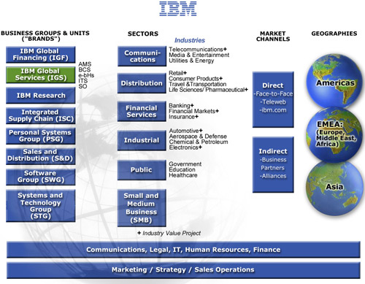
This engagement for JCPenney will be supported by IBM Global Services (IGS), the world’s largest business and technology consulting services provider with annual revenues of over $40 billion. The organizational chart depicting the IBM delivery team’s linkage to IGS senior management is provided in the diagram below.

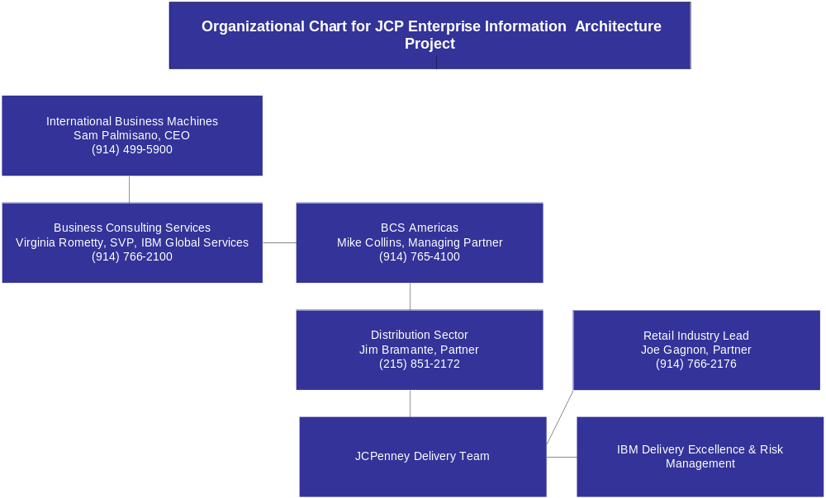

Financial Description
IBM’s total revenue in 2004 was $96 billion with a gross profit of nearly $36 billion. The total assets in 2004 were $110 billion with $79 billion in liabilities. IBM financial statements and the most recent quarterly earnings can be found on our Web site at: http://www.ibm.com/investor/financials/irfiqe.phtml. For further information, IBM’s 2004 annual report is available at http://www.ibm.com/annualreport/.

The most up-to-date credit report can be attained by accessing the Dun and Bradstreet Web site at http://www.dnb.com/dnbhome.htm. IBM's Dunn and Bradstreet number is 00-136-8083.

Additionally, IBM has provided the major rating agencies’ ratings of the Company’s debt securities as of December 31, 2004.

Major Rating Agencies’ Ratings of IBM Debt Securities
Category | Standard and Poor’s | Moody’s Investors Service | Fitch, Inc.
Senior long-term debt | A+ | A1 | AA-
Commercial paper | A-1 | Prime-1 | F-1+

Quality Assurance
IBM has an overriding commitment to the quality of its products, solutions and services provided to clients. IBM is committed to the goals of achieving total client satisfaction as well as delivering superior products, solutions and services by exceeding client requirements.
IBM Global Services follows a rigorous Quality Assurance discipline focused on providing high-quality business solutions in keeping with IBM's overall commitment to quality. IBM’s Quality Assurance discipline, called Delivery Excellence (DE), is integrated into our project management approach. The objective of Delivery Excellence is to recognize, contain and mitigate risks that would jeopardize the success of the project.
Specific steps that will be taken to provide high quality deliverables on this engagement for JCPenney include formal deliverable reviews and sign-off procedures, comprehensive unit and integration testing as well as outside Quality Assurance reviews performed regularly by IBM Delivery Excellence SME’s and dedicated risk managers.

References
The following IBM retail clients may be contacted to evaluate our qualifications to support JCPenney with this initiative:
 Circuit City Stores, Inc.
Circuit City Stores is a leading electronics retailer in the US, with more than 600 superstores across 45 states. The big box outlets offer a wide array of televisions, DVD players, and audio systems, as well as CDs and DVDs. Circuit City also sells personal computers and peripherals, mobile computing devices, telephones, and video games. In addition to its retail stores, the company sells products through its website. Circuit City also owns Canadian electronics retailer InterTAN.
For Circuit City, IBM is currently working with the IT group to develop and deliver an Enterprise Data Warehouse (EDW). This project is in its fifth phase and is comprised of the EDW and two data marts. In the fifth phase of the project IBM associates will be working with each business area to identify and prioritize their need for data. Currently the EDW has product, inventory and sales data along with associated dimensional data. Phase I was focused on the development of the EDW Strategy and Roadmap which identified the high level vision and strategy for the EDW and associated Tracks of work to realize the vision. Phase II included the design and implementation of the EDW Inventory Proof of Concept which included foundation components such as the Time, Location, and Product subject areas and the baseline component of the Inventory subject area. Phase III included continuing activities in the Supply Chain Track and initiated requirements and analysis activities for the Customer Track. In Phase IV the Inventory subject area was extended to include the In-Stock components. This activity included the implementation of In-Stock data in the EDW, and the creation of an In-Stock data mart for reporting and analysis of Inventory data.
As part of the evaluation process, IBM will provide access to our client:
Mr. Joe McCorey, Vice President Applications Circuit City Stores 9550 Maryland Drive Richmond, VA 23233
Please contact Mr. Joe Gagnon, Partner Business Consulting Services at 914-766-2176 to arrange an interview with Mr. McCorey.
 Children’s Place Retail Stores, Inc
The Children’s Place Retail Stores, Inc. is a leading specialty retailer of children’s merchandise, ages newborn to ten years old. The company designs, contracts, and sells high-quality, value-priced merchandise under the proprietary “The Children’s Place” and licensed “Disney Store” brand names. The company owns and operates over 750 The Children's Place stores, 309 Disney Stores in North America, and its online store, www.childrensplace.com.
For The Children’s Place (TCP), IBM is currently leading efforts to improve visibility into its point-of-sale information, through deployment of an enterprise data warehouse (EDW) based on a retail industry data model. IBM was engaged to implement the IBM Retail Enterprise Data Warehouse model as the foundation for this TCP EDW. In conjunction with TCP, IBM employed its Global BI Method to deploy the REDW solution. The TCP solution is currently in development, with a first release targeted for 2005 year-end deployment. The EDW is being deployed in IBM DB2 on p-Series servers, using the WebSphere Datastage ETL platform. TCP has been able to accelerate the critical data modeling activities and the overall delivery timeline for the first release, as well as establishing the foundation for subsequent releases across the enterprise.
As part of the evaluation process, IBM will provide access to our client:
Mr. Chris Camp, Director of Business Intelligence
The Children’s Place, Inc.
915 Secaucus Road
Secaucus, New Jersey 07094
Please Contact Jim Zalles at 512-633-0241 to arrange an interview with Mr. Camp.
 Kroger Stores, Inc.
Kroger is the nation's #1 pure grocery chain retail company. The company operates more than 3,750 stores coast-to-coast under more than two dozen banners (including about 2,530 supermarkets and multi-department stores). It also runs nearly 800 convenience stores under names such as Quik Stop and Kwik Shop. Kroger's Fred Meyer Stores subsidiary operates more than 125 supercenters, which offer groceries, general merchandise, and jewelry, in the western US.
For Kroger, IBM Business Consulting Services (IBM BCS) designed, developed, and managed the Enterprise Data Warehouse (EDW) data layer for an Operational Data Store (ODS) and Decision Support System (DSS). IBM BCS implemented the 24 TB data warehouse to facilitate category management and ultimately to provide insight for customer care strategies. The data warehouse is already having positive impact by supporting user access to the same quality and depth of information regardless of where they reside in the enterprise. The system enables reporting on 25 product hierarchies and over the next several years will drive Kroger’s specially targeted customer care strategies from a single location.

Kroger Stores Inc.
1014 Vine Street
Cincinnati, OH 45202
Please contact Shirley Waters, IBM Account Executive at 513-762-4480 to arrange an interview with a Kroger executive.

Electronic Data Exchange
JCPenney requires all suppliers to transact business electronically. Is your company capable of issuing invoices, receiving purchase orders, order cancellations, remittance advice and payment via EDI? If not, are you willing to do so?
Yes, IBM is capable of issuing invoices, receiving purchase orders, order cancellations, remittance and payment via EDI.

Project Description and Scope (RFI 2-I and 2-II)

Project Description
JCPenney is evaluating potential suppliers to provide consulting services in support of the development of an overall reporting and analytic information architecture framework that integrates on to their Enterprise Informational Architecture. The Plan is to improve the usability and availability of data with core operating applications. The selected vendor will assist with the planning, design and implementation of components in the overall Enterprise Information Architecture. The vendor will assist in the selection of the appropriate tools, and development of an overall implementation plan.
The vendor will also need to implement the plan on a very aggressive timeline.
Specifically, the goals of the project are to:
- Restructure existing data warehouse information into defined subject areas (Perform data gap analysis by business area).
- Provide conceptual information architecture frame work with defined key components
- Analyze reporting requirements to recommend how to effectively consolidate existing reports and create new reports that make better use of the data.
- Provide assessment of current tools and new tools that are flexible for future technology and business needs.
- Provide Business Intelligence on Meta Data for SOX compliance.
- Provide working prototype
- Implement “Electronic” workplace with customizable portal/dashboard by area of responsibility or individual needs as defined below

JCPenney Project Scope Objectives
Development of the “Electronic” workplace
- Provide “Self-service” environment for business users “pushing” information that is tailored to the business Analyst’s capabilities allowing business units to identify opportunities to increase sales, improve margin, and reduce cost.
- Improve efficiency with the elimination of manual data gathering and manipulation processes to allow focus on analysis
- JCPenney will provide Reporting with Business Analytics with “what if” functionality in a Dashboard presentation
- Provide Enterprise Information portal that allows access to integrated corporate data for Finance, Merchandise, Direct, Store, Logistics, Marketing and HR.

Development of a Roadmap to Data Governance
- Eliminate redundant information, providing a “single version of the truth”.
- Implement ETL Process
- Restructure and eliminate need for excessive Data Marts.
- Implement OLAP functionality
- One set of data quality metrics- Key Performance Indicators (KPI)’s

Develop architecture and plan that will effectively support Strategic Business projects identified in our 5 year plan such as
- Retail – SPEED to Market
- HR – Winning Together
- Finance – One version of the truth
- Multi-Channel - Retail Stores, Catalog, Internet

IBM has reviewed the project description and scope and understands the strategic importance of the Enterprise Information Architecture initiative. We demonstrate our understanding within sections 3 and 4 where we have provided a recommended approach and technical architecture to meet the objectives of the project.

IBM Approach

Approach – Overview
IBM understands the project description and scope and we have provided an approach that will assist JCPenney in achieving the objectives specified in the RFI and that will meet the aggressive timeline. Our Approach is based on IBM’s BI Methodology that has been used on many customer engagements for the design and deployment of an Enterprise Information Architecture or data warehouse. We have customized our methodology to meet JCPenney’s requirements and to specifically improve the efficiency and effectiveness of cross department and cross channel financial reporting. Additionally, JCPenney has already made significant investment in tools like MicroStrategy and DB2 that can be leveraged. IBM recommends putting more focus on value-added activities like validation of requirements and comparison to leading practices instead of generic feature function comparison of tools and “greenfield” requirements gathering approaches.
Following are some of the key elements of the differentiated IBM approach that will get JCPenney to a holistic solution that provides business value, faster:
- Leverage JCPenney’s existing infrastructure and tools like MicroStrategy, DB2 and other tools you are already considering like Alphablox and WebSphere Data Integration Suite (formerly called Ascential) to expedite the time to business value, prove out the technology and achieve the aggressive timeline.
- Use of IBM’s RBIS and other project accelerators like tool selection templates and leading practices
- Leverage IBM’s Toronto Lab facility to expedite and demonstrate product capabilities including Balanced Configuration Unit (BCU) functionality, and to provide an initial development environment. The BCU has business intelligence technology components that are individually optimized for high performance and tested end-to-end to help provide optimal, predictable performance and scalability, lowering total cost of ownership.
- A focus on using the financial subject area to demonstrate transition plan and BCU capabilities
- Deployment of an architecture that can be extended beyond the initial phase to provide cross-enterprise information and analysis
- Ability to provide a solution that addresses the growing need to support external information consumers and supply metadata and data traceability due to evolving business models and a changing regulatory environment (SOX)
- Alignment of enterprise portals for personalized delivery, and knowledge management for context
- Providing a solution that minimizes the amount of time spent on gathering and cleansing data allowing finance resources more time to analyze data.
- Service Oriented Architecture (SOA) driven approach that will help operationalize the business insight and allow JCPenney to quickly adapt to changing business conditions in the future

Approach - Key Activities
The first step in moving JCPenney to this type of integrated information environment is the development of a Business Intelligence Strategy, Solution Outline and Enterprise Roadmap to guide the project. IBM’s customized approach will leverage not only a traditional proven methodology, but a methodology that has been leveraged within the retail industry and has embedded accelerators that will help JCPenney meet their timelines and reduce cost over other traditional approaches that use a standard requirements gathering and tool selection. In addition, our approach will address the challenges related to financial reporting through specific project tasks to evaluate the existing financial reporting environment and to implement the technical and process changes necessary to achieve efficient, consistent and accurate financial reporting.
IBM’s approach to designing and developing BI solutions is multi-phased; each phase building upon those that preceded it. This incremental and iterative approach allows the team to further refine both the design and the release strategy before construction begins and allows IBM to help JCPenney assess the viability of the solution in each phase throughout the engagement. The major activities of our standard approach across the entire BI project lifecycle are depicted in the figure below for completeness, with descriptions of each phase, activities and deliverables specific to this engagement following.

Standard Methodology
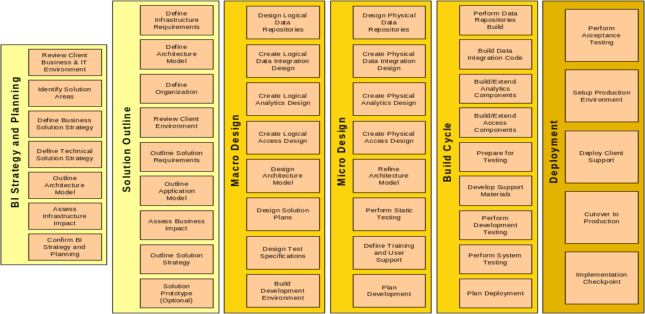

Value of our BI Method
Differentiators | Benefits
- Industry-leading, best-in-class content  - Proven, track record of successful implementations  - Comprehensive: lifecycle, including integrated BI strategy  and planning  - Leverages full IBM methods for systems, infrastructure  - More than just a standalone method: tightly linked with IBM  BI reference architecture  - Open to best of breed technology  - “Tailorable”, flexible, allowing for integration of finance KPI  and process improvement activities  - Globally used in our BI practice  - Integrated with other IBM methods (project management, risk management, etc)  - Linked to and leverages our extensive library of work products and accelerators culled from hundreds of BI projects | - Focuses on both business aspects and technical aspects  of BI  - Increases likelihood of successful BI strategy and  implementation  - Facilitates successful delivery of global, multinational  projects  - Provides better accuracy in project cost estimation  - Thought-provoking content, think outside the box;  challenge your thinking  - Provides a “safety net”; things won’t fall through the  cracks  - Comfort factor; helps sell project internally  - Facilitates knowledge transfer to client staff  - Economical – avoids the need to reinvent the wheel

Strategy and Planning (Phase I)
The purpose of the BI Strategy and Planning activity is to define and validate an integrated Business Intelligence vision for the organization and adopt a common framework around BI needs, solutions and approaches. IBM’s approach expedites this phase by validating Requirements against IBM’s Retail Data Warehouse (REDW) and the Retail Business Solution Templates which have been utilized in other retail engagements.
Activities/Objectives
- Define and validate JCPenney’s BI vision, value proposition & priorities for the organization
- Review and confirm current financial reporting issues
- Leverage IBM’s RBIS to adopt a common framework around BI needs, solutions and approaches.
- Assess JCPenney’s existing initiatives and impact/dependencies on this environment
- Assess JCPenney’s current capabilities (architecture, tools, reporting, etc.)
- Outline future state
- Prioritize initiatives and develop the phased integrated roadmap
- Define the project’s governance approach, guiding principles and procedures
- Develop the high level business case to support the finance rollout and prioritization of other functional areas
- Conduct a leading practices and guiding principles workshop to educate JCPenney resources on retail BI leading practices

Solution Outline (Phase I)
The purpose of the Solution Outline activity is to provide a scoping validation in which the solution complexity, architecture, and scope are defined and the overall strategy and approach for the design and implementation effort is developed. Additionally, the business case is articulated with prioritized functionality and subject areas. This allows a more detailed estimate of the phase costs, benefits, schedule and other key information to help you make an informed investment decision regarding a potential new solution before additional resources are expended on more work. Leading practice tool functionality will be leveraged to create system requirements for tool validation/selection. Although our approach does not include an RFI and/or RFP for tool selection, these could easily be developed from the requirements and accelerators.

Activities/Objectives
- Define/validate the components of the solution (business, architecture, organization) including tool validation/selection (OLAP, ETL)
- Create a conceptual, high-level view of the solution (long term and for initial roll-out)
- Scope the selected business solution identified under BI strategy roadmap
- Evaluate financial reporting processes
- Define and validate business requirements and key performance indicators
- Outline solution
- Perform a gap analysis vs. the recommended architecture
- Validate high-level conceptual data model from RBIS
- Identify potential data sources
- Gather usability / user interface requirements
- Assess organizational impact
- Outline solution deployment and transition strategy
- Develop metadata strategy
- Develop data quality and governance strategy
- Define key analytic use cases

Macro Design (Phase I, Phase II)
The purpose of the Macro Design activity is to lay the groundwork in preparing for the Release phases by developing architecture, designed to withstand many business changes through the delivery of the solution releases and beyond. Macro Design moves the focus from business to the solution’s technology strategy, addressing the global, architectural issues that affect the releases. The standards, guidelines and architectural work products developed in the Macro Design phase are designed to help minimize long term development cost by reducing rework, from release to release.

Activities/Objectives
- Top-level, logical design for the BI solution including the data integration system, the data repositories, the analytics system and the access system
- Design architecture model
- Finalize technology selections
- Design solution deployment plans
- Build development environment by leveraging IBM’s Toronto Lab environment
- Initiate iterative prototype development

Micro Design (Phase II)
The purpose of Micro Design is to prepare for the build cycle of a specific release of the solution by driving the architecture and design to a release specific and implementation platform view. Micro Design is the first of three sub-phases repeated for each Release Phase of the solution. Whereas Solution Outline and Macro Design phases take a release independent view, Micro Design focuses on a specific release. Micro Design refines many of the same project outputs addressed in the prior two phases but narrows the scope to the release and goes to a greater level of detail.
The Micro Design activities for this initiative would focus on the initial finance solution to be deployed in Phase 3.

Activities/Objectives
- Develop final set of blueprints for building the solution
- Create physical design for the BI solution including the data integration system, data repositories, analytics system and the access system
- Design new financial reporting processes
- Refine architecture model
- Perform walk-through
- Develop test plans (system, integration)
- Create detailed design specifications for the financial reports and KPI’s

Build (Phase II)
The objective of the Build Cycle sub-phase is the development and testing of the solution Release. This is an iterative process with each Build Cycle containing several incremental programming and testing cycles. An assessment of business conditions and validation of the release strategy is performed before the construction of each release to provide an opportunity to adjust the design and release strategy to help respond to changes in business conditions.

Activities/Objectives
- Construct the BI solution including the data integration system, the data repositories, the analytics system and the access system
- Configure BI solution components
- Build data cleansing routines
- Perform unit testing
- Perform system, integration testing
- Load data structures with test data
- Perform initial performance tuning
- Finalize deployment plans
- Develop user training
- Release system to Beta users

Deploy (Phase III)
The objective of this sub-phase is the managed roll out of the solution Release. The migration of users from other systems and the required data conversions also are managed in this phase. Each release is evaluated and the results fed back into the assessment of the next release. A pilot may be used to verify that each release functions as expected.

Activities/Objectives
- Implement the BI solution in a “production” environment
- Deploy the system to the finance community
- Train user community
- Perform user acceptance testing
- Load historical data
- Configure system management tools (scheduling, monitoring)
- Obtain management approval for production cutover
- Prepare systems implementation report

Approach Accelerators
Our approach to the Enterprise Information Architecture/Data Warehouse project will allow JCPenney to identify and avoid large investments by establishing a strategic long term architecture that is balanced against short term needs. Developing the logical architecture in advance permits JCPenney to avoid significant future costs. Developing the long-term architecture early in the process resolves major design considerations such as those noted below:
- Addressing the needs of business users whose information requirements are currently being met by stand alone data marts servicing their specific functions
- Avoiding just recreating old reports on a new system
- Understanding the requirements (frequency and currency) and associated benefits and costs associated with an Operational Data Store (ODS)
- Understanding configuration options for the warehouse environment, centralized or regionalized, hosted or internal, on-shore or offshore, etc.
- Modeling the user access experience to facilitate, integrate and automate business processes while providing a “secure” role based personalized experience that drives operational improvements
Addressing the logical, long-term architecture up front, while balancing delivery of real measurable business value and function on a continuous basis, is also necessary to confirm the feasibility of JCPenney’s high-level 5 year vision. In a recent enterprise data warehouse project for a client, this approach assisted in identifying opportunities for reducing forty percent of their annual enterprise DW development and maintenance budget, equating to several millions of dollars in savings.
Designing and implementing an appropriate governance framework that addresses organization, process and data is also critical toward keeping a program as large and complex as this aligned with the business value. It is especially important in establishing and maintaining corporate-wide standards for data, tools/technology, and processes. It has been our experience that without effective governance, which includes the active participation of business and technology stakeholders, the current situation of a fractured and siloed data warehousing environment will be repeated as organizations continue to demand more information that limits the organization’s ability to respond to shifting business priorities in a timely fashion.
Most importantly, our approach will utilize our Retail Business Intelligence Solution (RBIS) toolkit to deliver JCPenney’s business objectives with lower overall risk and expedited timeframe. IBM’s RBIS includes:
- Retail Business Intelligence Reference Architecture and Association for Retail Technology Standards (ARTS) Compliant Enterprise Data Warehouse Model that has been successfully leveraged by other retailers.
- Retail Optimized Business Intelligence Infrastructure (server, storage and software)
- Retail specific templates for quick start analytics and reporting for Corporate Financial Management, Store Operations, Merchandising, Customer Management, Product Management and Multi-Channel
- Retail Design and Implementation Services to help retailers prioritize their high business impact areas and allow for an easy deployment
The RBIS Retail Enterprise Data Warehouse Model (REDW) provides a well-organized, fast, and easy to access repository of analytics and metrics to support Business Performance Management and provide for “activity based monitoring” for real-time (on-demand) action to address business conditions in workplaces. It actually contains three models:
1. Retail Data Warehouse Model (RDWM)
RDWM, an ARTS compliant data model, will enable JCPenney to consolidate the data from throughout the enterprise into one view. It is an enterprise-wide logical entity-relationship data model. It contains over 70 subject areas, over 600 entities and over 4,000 attributes. The objects in the model are fully defined and documented. It includes commonly required summaries and sample analysis schemas. It is a low-level flexible model, generic and one step from a physical model.
2. Retail Business Solution Templates (RBSTs)
The Retail Business Solution templates are a grouping of measures and dimensions that fulfill a particular business requirement. It organizes the data into specific areas for advanced analysis. RBSTs address typical reporting requirements in the areas of Corporate Finance Management, Merchandising Management, Products and Services Management, Store Operations Management and Customer Management. It provides Data Mart Templates for retail organizations, and enables fast accurate requirements gathering.
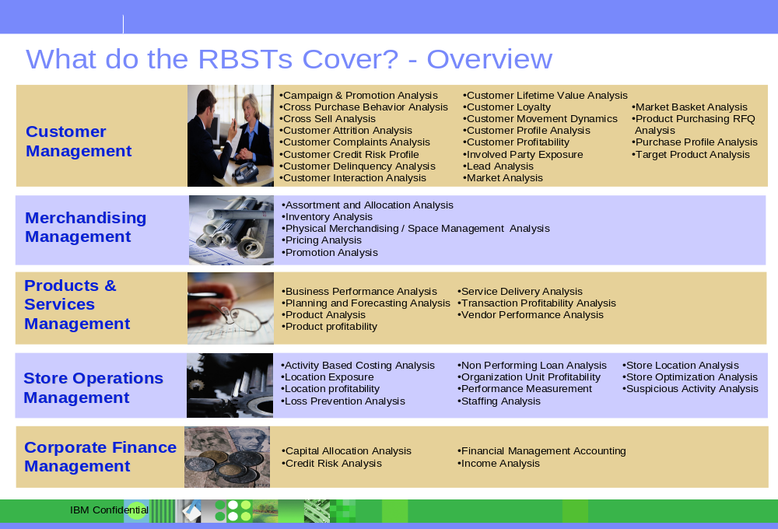
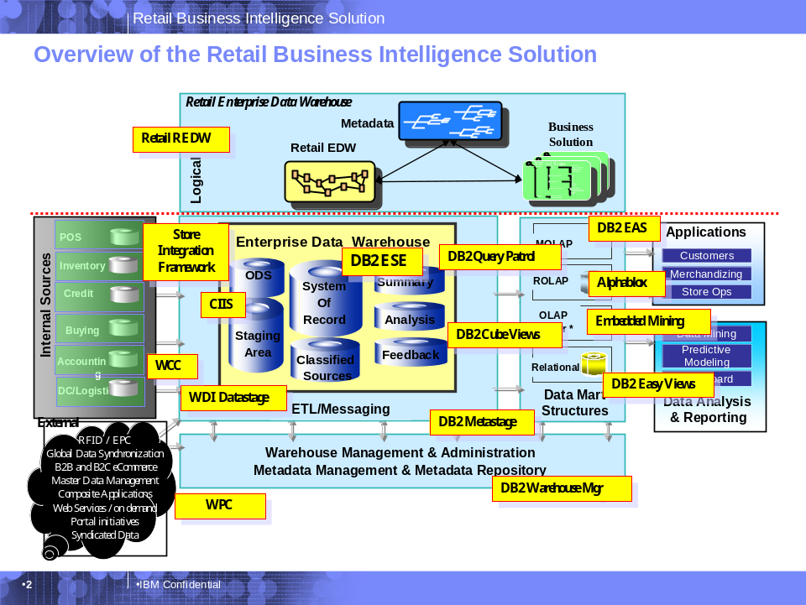

3. Retail Services Data Model (RSDM)
The Retail Services Data Model provides an overall corporate model with common language & terms. RSDM is a Business Classification Model for retailers. It is a classification breakdown of the data required and/or used by the retailer. It contains both model structure and data content.
IBM will leverage the RBIS tools to accelerate the requirements gathering, data mapping and tool validation by enabling:
- A starting point for a consistent view of information across the enterprise with an integrated framework and toolset.
- Quick identification and delivery of advanced analytics and insight into core Retail process areas (see diagram below)
- Rapid, phased deployment
- A packaged, customizable, open environment

The following diagram highlights how the RBIS framework is used to adapt and streamline IBM’s BI methodology, specifically to retail and JCPenney.

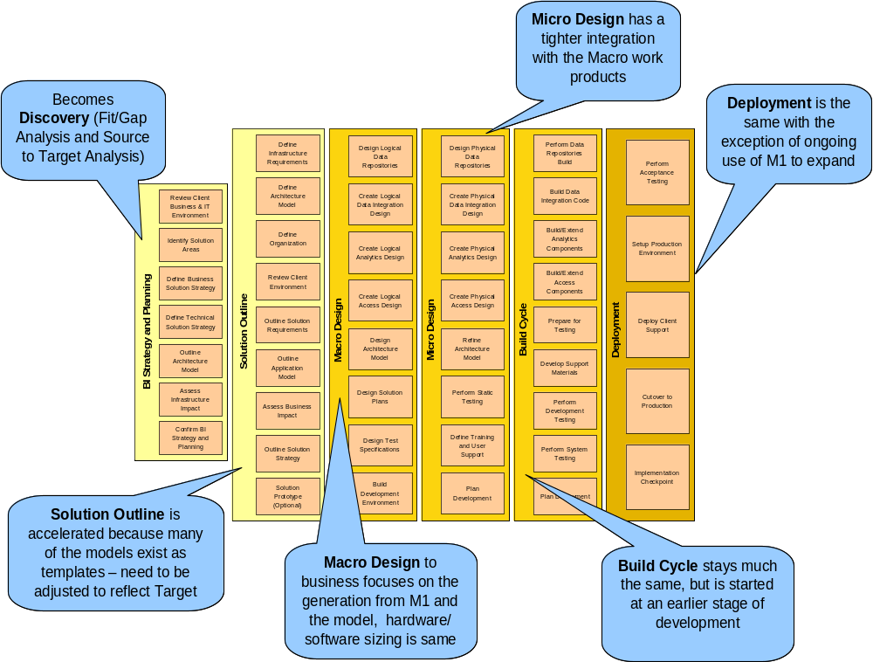

To summarize, the approach suggested by IBM, encompassing process, people and technology, offers a more holistic and focused solution to help meet JCPenney’s business needs. Additionally, our approach leverages our significant experience and knowledge in Business Intelligence, Financial Reporting and Retail creating an offering with the potential to reduce design and development costs and gain additional business value beginning with the Beta release, thus helping to achieve your cost objectives. This allows JCPenney to gain business support, facilitate adoption, and obtain momentum early in the process.
Lastly, our approach will leverage the Toronto IBM Labs to expedite development of the prototype. This lab environment is already being used by JCPenney to support some of their testing and development. Our approach will also use the financial subject area to demonstrate the value of the BCU architecture and the transition plan. This will allow JCPenney the opportunity to “pilot” the entire architecture and transition plan. Our approach is taiolored toward developing the roadmap and transition plan to achieve your long-term vision and objectives in an expedited timeframe with lower overall risk.

Our Approach Supports Development of the “Electronic” Workplace for JCPenney
Our approach and recommended architecture includes the design and deployment of an enterprise portal framework. To meet productivity and information needs, many retail organizations are turning to the flexibility and capabilities of portals. Our portal solution approach provides a single, secure, personalized interface that integrates people, processes, applications and information. Additionally, this approach supports information access by many different constituencies like consumers, employees, vendors and partners. By integrating the delivery of information, business intelligence and analytics through a portal, our approach will give employees access to data crucial to performing their particular jobs, thereby improving overall productivity, increasing customer satisfaction, enhancing business responsiveness and maintaining a competitive edge. Although the goal of most organizations is to move to a “one stop shop” for information, our experience shows that an interim goal of having a “first stop show” for information is a reasonable strategy. In light of that, our portal approach supports building upon the environment incrementally and creating business value along the way.
IBM’s approach to building an enterprise information portal will help JCPenney provide an “Electronic” workplace customizable by area of responsibility or individuals needs by:

- Providing the framework for the development of a “Self-service” environment for business users “pushing” information that is tailored to the business analyst’s capabilities thereby allowing business units to identify opportunities to increase sales, improve margin, and reduce cost.
- Providing the framework for the display of reporting with business analytics and “what if” functionality.
- Providing the framework for the development of access to integrated corporate data for Finance in the initial phase and Merchandise, Direct, Store, Logistics, Marketing and HR in the future phases
- Providing a services oriented framework to quickly deploy new information tailored to the user regardless of the type and location of the device being used to access this information

Creating the Ideal Infrastructure for Portals
A service-oriented architecture (SOA) is the ideal foundation for a retail portal. An SOA is a technical architecture that takes everyday business applications, such as financial management systems, customer relationship management (CRM) systems or inventory tracking, and breaks them down into individual business functions and processes, called services.
Our approach emphasizes defining the key business functions and processes required to meet JCPenney’s strategic goals for the EIA solution and delivering them in the form of services. Each service can then be combined and reused in a portal environment to support the different activities and changing needs of JCPenney. A service could be a business function such as check sales by store or a system capability such as login user. The role of the portal is to act as the delivery mechanism for services, aggregating them and exposing them to each unique audience in a secure and personalized way.
Enterprise Portal Example:
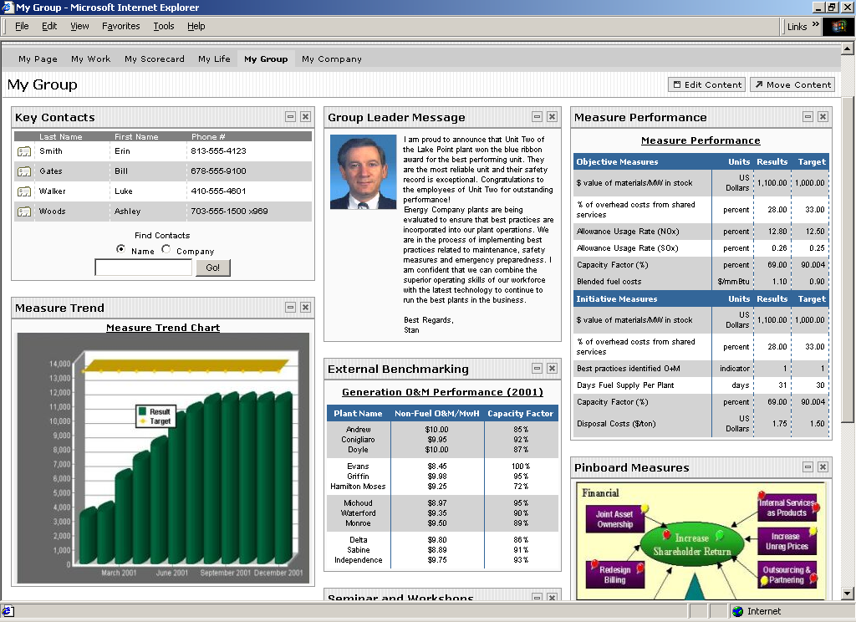
It often makes sense for a retail portal to be personalized depending on the user’s role. For instance, a merchandise manager’s portal page can provide a consolidated view of product order history, current inventory levels, projected lead times and current targeted marketing activity— in a single view. With the information in one place, the manager can make more-informed decisions and forecast what current product sales might be.
To further improve productivity and streamline business processes, multiple portal applications, or portlets, can be choreographed to facilitate the execution of an end-to-end process (which can be especially useful when multiple people are involved in a single business process). In the case of merchandising, different portlets and personalized portal pages can be created for the individual users involved: the store associate, buyer, store manager and merchandise manager. Each audience can then use the portal for a variety of purposes, yet the portal would capture and deliver the information relevant for each user, while providing a unified view.
The componentization of business processes also allows retailers to extend those processes (in the form of services) to customers, partners and suppliers as warranted, or recombine them as new market opportunities arise.

Our Approach supports Development of a Roadmap to Data Governance

Most organizations, as part of their overall commitment to quality and innovation, must change and apply more focus on improving the reliability and transparency of company information. Additionally, transforming a business to value the quality and timeliness of its information asset becomes part of the “dashboard” for running the business daily. A holistic Information Management Framework is vital to an organization that is struggling with the accuracy, timeliness and/or transparency of their company’s data.
The benefits expected from major technology investments like ERP, Data Warehouse, Supply Chain, and Customer Relationship Management are dependent upon establishing and maintaining a “certified” information management environment based upon enterprise wide business measures and data standards delivered through enabling technologies, business processes, organization and governance. Most of these big technology projects that are not utilizing data quality procedures are not producing the expected business value because data from these systems cannot drive the business without further investigation, integration, coordination and value-add from analysts, accountants or auditors.
Regardless of an organization’s commitment around financial data quality, federally mandated laws like Sarbanes-Oxley in the United States mandate building absolute trust in the information being used within an organization, along with the environment and analytic tools that will use that information.
IBM’s approach will help JCPenney create the vital framework that is necessary to make information a strategic asset and competitive weapon for the organization by using our methodology, tools, templates and retail business intelligence experience to integrate and deliver the following key components, along with the supporting organizational and governance structures.
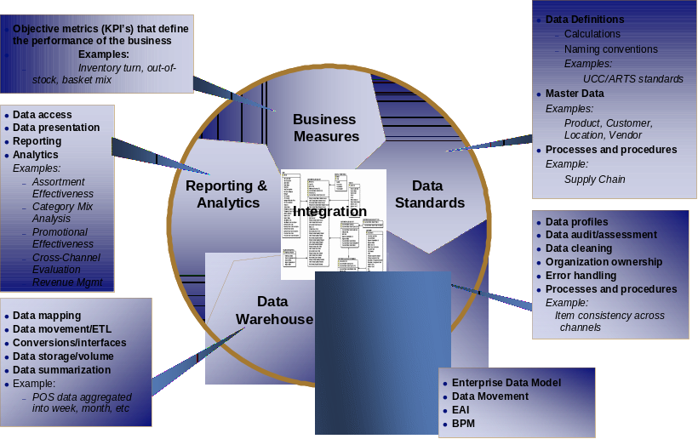

Building absolute trust in JCPenney’s information requires enabling the JCPenney management, employees, partners, customers and shareholders around the world to not only utilize, but value and be measured on the (6) key areas related to information management outline above. An organization that is aligned with a holistic and integrated Information Management framework, no matter what form it takes (virtual, central or distributed) can build global / system-wide organizational consistency across these six areas by including people from each part of the organization to design, develop, implement, support and improve the organization’s information assets. IBM’s team has experience in creating these types of organizations, not only on paper, but helping implement them. This new organization and governance can take on a number of different structures; however, it should be a sustaining concept and perpetual framework within the organization. It should be sustainable long after any single project. Our approach will help JCPenney evaluate different governance concepts (leveraging leading practices) that will ultimately drive to a model that is right for JCPenney.

Enterprise Architecture Solution (RFI Pages 7-9)

IBM’s Approach to the Overall Solution: Provides Benefits to JCPenney
IBM is confident in the strengths of its Relational Database Management System (RDBMS), server platforms, and Business Intelligence Suite of products including WebSphere Data Integration Suite (formerly called Ascential) and AlphaBlox and their abilities to meet or exceed JCPenney’s requirements. IBM has concluded that the approach which provides the highest overall benefit and quickest path to business value to JCPenney is to continue to leverage the significant investments JCPenney has made to date in MicroStrategy and the current server and Database Management System DB2 platform.
Therefore, it is our assessment that JCPenney’s need is not necessarily a traditional tool election for new technology. Rather, it is to complement your team with experienced, senior Business Intelligence/Data Warehouse/Enterprise Architecture consultants who have the requisite skills to design, build, and provide your next generation DW architecture utilizing a map and gap approach with our Retail Business Intelligence Solution (RBIS). As such, we believe IBM’s market-recognized leadership in delivering BI/DW capabilities can provide JCPenney unmatched business and technical expertise in architecting, designing and deploying your DW solutions.
Our approach proposes a future Enterprise Information Architecture (EIA) which leverages investments in the current architecture, identifies gaps by mapping to IBM’s Business Intelligence Reference Architecture, and recommends tools to address gaps. During Phase I of the project, this proposed EIA and the recommended tools/products will be validated. Proposing the architecture in advance permits JCPenney to avoid significant future costs and a lengthy tool selection process.

JCPenney’s attainment of the benefits from Strategic Initiatives requires an enterprise information environment which enables Information On Demand. JCPenney can leverage IBM’s Information on Demand capability to help build and deploy an enterprise information framework, architecture, and services to achieve their strategic goals. IBM’s Information On Demand capability can also help JCPenney operationalize and “push” business insights gained to business users and processes at the right time. Utilizing Service Oriented Architecture (SOA) based services, real time information can be integrated with JCPenney business processes (strategic, financial and operational) through portals, devices, workflow, and web services to deliver the business benefits and ROI.

In summary, a key differentiator in our approach is that the architectural design has been done and will be validated during Phase 1. An elongated tool selection will not be required, and our team will begin day one on the project productive in working towards delivering the proposed environment.

Current Enterprise Information Architecture

The current state of the Enterprise Information Architecture uses an assortment of analysis and reporting tools directly accessing data repositories which are Operational Data Store structures (see below). Reporting is produced in a variety of forms reflecting the capabilities of the various tools.

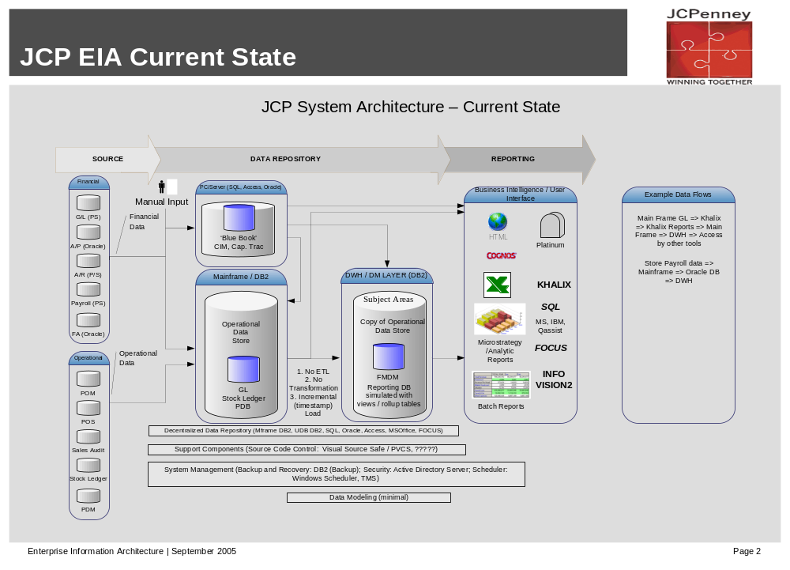
Mapping JCPenney’s EIA to IBM’s Business Intelligence Reference Architecture identifies gaps in the EIA Conceptual Design capabilities. In the diagram below JCPenney tools/products are indicated in red, and recommended IBM tools/products to address gaps are indicated in blue. As the leading Business Intelligence solution and service provider, IBM is experienced in deployment of the components needed to fill the gaps of this architecture.

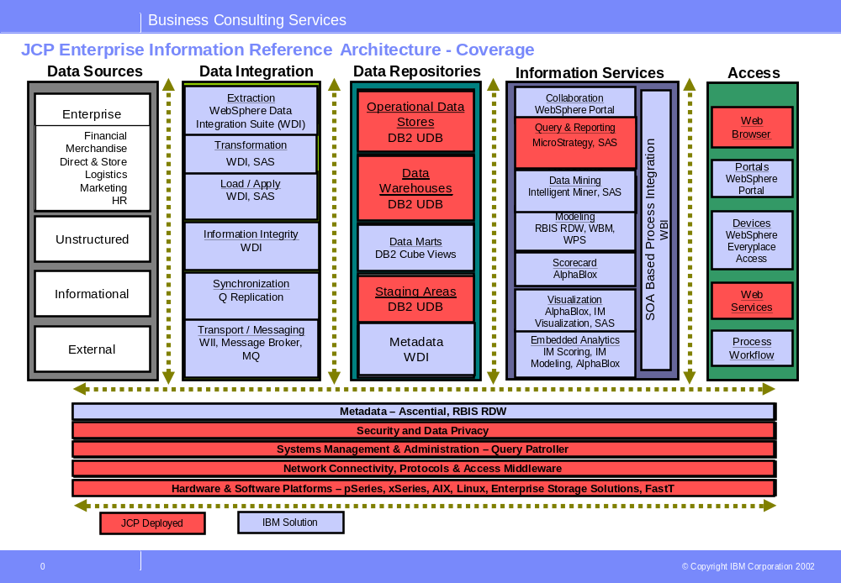
The capabilities required from each of the BI Reference Architecture components are necessary to achieve a true Information On Demand environment. As part of IBM’s reference architecture, we recommend JCPenney implement the key capabilities outlined in the Data Integration Layer to deliver a high degree of information integrity in their Data Repositories.

The BI Reference Architecture provides the framework to address JCPenney strategic initiatives. As indicated below, specific architecture layers and components can directly support strategic initiatives:

Finance – One Version of the Truth
Information Services Layer accelerators which allow rapid deployment of reporting and analytical templates for Store Operations Management in areas such as Staffing Analysis, Store Optimization Analysis
The Data Warehouse will be the source for the simple version of the truth, where the reporting content will originate
Data Integration Layer which links and consolidates store (“retail”), direct as well as private brand financial information for consolidated reporting
Drill back capability via the Information Services and Data Repository Layers to facilitate exploration of consolidated financial reporting back to individual channel group financials
Information Services Layer enabling real time scorecards with near-current flash reporting
Security and Data Privacy components integrated with Data Repositories which prevent unauthorized access to confidential financial information
Information Services Layer tools which provide flexibility for user defined reporting and analytics
Integrated Information Services and Data Repository Layers with the Metadata component enabling enterprise data standards and reporting/analytics/scorecard rapid deployment
SOA approach will help integrate and “push” the required financial information into financial business processes (specifically related to Sarbanes-Oxley Act)
SOA approach will also provide the flexibility to quickly adapt to changes driven by regulatory and business issues.

SPEED – Retail Speed to Market
Information Services Layer accelerators which allow rapid deployment of reporting and analytics via templates for Merchandising Management in areas such as Assortment and Allocation Analysis, Pricing Analysis, Promotion Analysis
Information Services Layer providing modeling and what-if analysis to test new product potential
Data Integration Layer incorporating external data including competitor market penetration to assist in identifying candidate products
Information Services Layer providing Real Time analytics and information
Data Integration Layer which links Supply Chain/Logistics data with Sales and Replenishment information which enables evaluation of sufficient Supply Chain capacity to support new products
Access Layer providing collaboration with merchandise sourcing partners to expedite new product procurement
Data Repository Layer which combines historical trend data with real time operational data to rapidly assess merchandise launch effectiveness
SOA approach using web services will help easily and securely collaborate with suppliers to reduce cycle times in areas of product development, order management, and fulfillment.

Multi Channel
Information services layer will allow centralized assortment planning and allocation regardless of channel or location lowering overall cost of assortment management while improving revenue and margins due to improved allocations.
Information services layer will provide ability to set competitive pricing from a centralized process using localized, channel specific, and multi-channel data.
Information services layer will allow ability to push “real time” promotional strategies across channels – push to PDA, POS, eCommerce website, etc based on customer or transaction specific triggers.
Information services layer will allow harmonization of product information across multiple channels.
Information Services Layer accelerators which allow rapid deployment of reporting and analytical templates for e-Commerce Analysis, Catalog Analysis and Call Center Performance
Information Services Layer accelerators which allow rapid deployment of reporting and analytical templates for Assortment and Allocation Analysis, Pricing Analysis, Promotion Analysis and Call Center Performance
SOA approach will provide ability to quickly add new devices such as POS, PDA’s, handhelds, Kiosks, etc regardless of channel.

HR – Winning Together
Information Services Layer accelerators which allow rapid deployment of reporting and analytical templates for Store Operations Management in areas such as Staffing Analysis, Store Optimization Analysis
Access Layer which empowers associates with process workflow integration leveraging knowledge from Business Intelligence
Access Layer which is capable of assisting with associates and management development by delivering learning and knowledge content enriched by associate profile data
SOA approach will allow business users to easily tailor information to their specific needs with minimal involvement from IT resources to be more responsive to customer and business needs.

Proposed Enterprise Information Architecture
The diagram below is the JCPenney EIA Conceptual Design, with recommended IBM software and solutions included. These recommended products address gaps in the current architecture, and will provide an overall robust architecture to address current JCPenney strategic initiatives and provide flexibility for deployment of future subject areas.
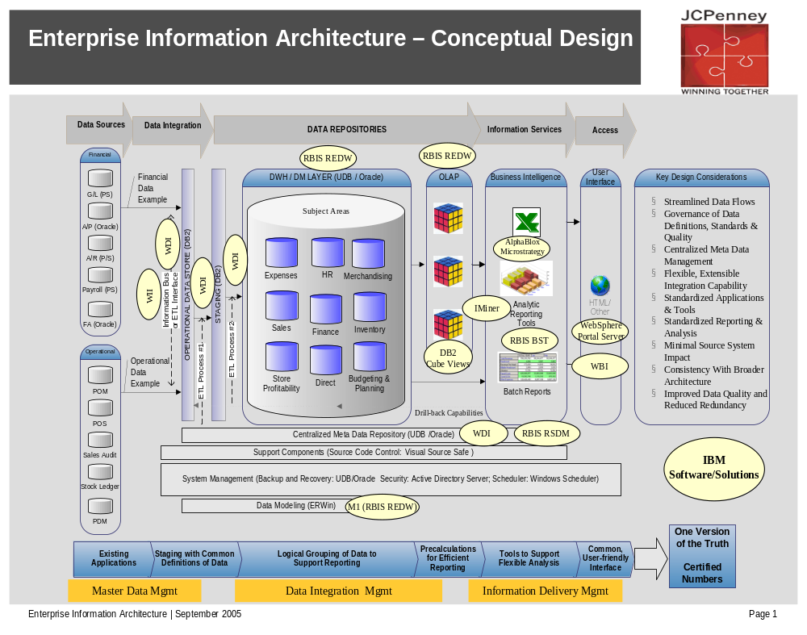
A description of each of the recommended products and how they contribute to the EIA Conceptual Design follows.

Master Data Management
Staging with Common Definitions of Data
WebSphere Data Integration Suite (formerly called Ascential) is a transport mechanism for moving data from sources and extracts, transforms and loads the data into the ODS or DW Staging areas. IBM’s RBIS Retail Data Model (REDW) contains industry best practice subject area structures which accelerate Staging design.

Data Integration Management
Logical Grouping of Data to Support Reporting
RBIS Retail Data Model (REDW) includes key retail concepts, logically grouped entities and attributes in a relational model organized by Subject Area. The RBIS modeling tool (M1) allows for easy customization for JCPenney custom requirements, while maintaining data definitions and related metadata in a separate metamodel, Retail Services Data Model (RSDM).

Pre-calculations for Efficient Reporting
The transformation of normalized data structures to dimensional structures enable flexible and efficient reporting. The RBIS Data Model contains dimensional structures to support pre-defined reporting templates (Business Solution Templates) supplied through the RBIS solution. Where appropriate, the dimensional structures contain aggregated (pre-calculated) data for efficient reporting. Additional efficiency is realized by implementing dimensional structures utilizing DB2 Cube Views.
Information Delivery Management
Tools to Support Flexible Analysis
The reporting and analytical toolset consists of AlphaBlox, MicroStrategy and Intelligent Miner. Each tool has a niche, MicroStrategy for reporting and typical OLAP navigation capability, AlphaBlox for very customizable information analysis with integration of various object types, and IMiner for Modeling, Scoring and Visualizations for data mining based analytics.

IBM Response to JCPenney Architecture Statements
Existing Applications
  - What we know
    - Hardware – IBM, HP/UX, AS400, Tandem, NCR, SUN,
    - Operating Systems – Z/OS, Linux, Unix, Sun Solaris, AIX, Teradata

IBM’s approach will leverage JCPenney’s existing technical infrastructure to the extent possible.

Staging with Common Definitions of Data
  - What we know
    - Data will be moved with an ETL process and transformed into correct data type using a Data Modeling tool
    - Support Components will not change.
    - Security and Scheduler will not change
    - Data will only be moved one time from Legacy to Warehouse.
    - What we don’t know
    - Which ETL and Data Modeling Tool to use
    - Implementation of tool into the current process.
  - System Management needed for Backup and Recovery for UDB and Oracle. along with procedures for defining the Backup and Recovery process
IBM recommends the use of DataStage for ETL. IBM recommends the use of ERWin or M1 or a similar product for data modeling. The ETL tool will easily fit into the current process as it can be programmed to pick up the data one time from legacy to data warehouse. The ETL scheduling can be coordinated with the current scheduler used. Backup and recovery for UDB and Oracle can use the standard utilities delivered with those database management systems (DBMSs). IBM can provide procedures for defining the backup and recovery process based on the requirements for recoverability.

Logical Grouping of Data to Support Reporting
- What we Know
- Database software will be UDB and Oracle (depending on the application).
- The databases will change to provide new Data Modeling process.
- Centralized Meta Data Repository may need to change
- Not all databases are defined today in the warehouse.
- What we don’t know
- How data needs to be setup for OLAP tool.
IBM can select the manner in which the data needs to be stored and aggregated based on the requirements and the specifics of a tool, such as MicroStrategy.

Pre calculations for Efficient Reporting
      - What we know
      - We need an OLAP Tool
      - We want the tool to reside on the database hardware.
- What we don’t know
      - Which OLAP tool to purchase
      - How the tool needs to be implemented.
IBM can perform a tool study if required. However, IBM recommends the use of MicroStrategy. IBM will recommend “how” the tool needs to be implemented during the Strategy and Planning phase of the project, e.g. phase 1.

Tools to Support Flexible Analysis
      - What we know
- Tool must have Drill Back Capabilities to Legacy Data
- Tool need to have batch report process
- Will need have scheduling and subscribing function
- Security for multiply level reporting
- Tool must have ‘What If’ capability
- What we don’t know
        - What products are available?
IBM can analyze the capabilities and requirements specified and compare those against a MicroStrategy solution for gaps.

Common User – Friendly Interface
        - What we know
            - Must be Portal and customizable
            - User Friendly
          - What we don’t know
- What products are available?
IBM recommends using WebSphere Portal as the vehicle to deliver the common user interface. Portals/portlets will display business insights from analytical tools. The portal application will connect with WebSphere Business Integrator (WBI) to integrate business insights into business processes using SOA based services and deliver secure, personalized business insight through any device at the desired location.

Project Timeline (RFI Section III)
Project timeline for Phase 1 will begin mid-January 2006 and completed at the end of March 2006. This is the design component of the project. This will not include the build of the prototype but will include the design for the prototype.
The project timeline for Phase 2 will start in the beginning of March 2006 and be completed at the end of June 2006. This phase will include Macro Design, Micro Design, and Build activities in the BI method. This phase will also include build of the finance prototype and the release of the prototype to the beta users.
Phase 3 will include deployment of the finance common reports to additional users above and beyond the beta users. This phase will also include additional training and change management.
A workplan for the project is provided below:
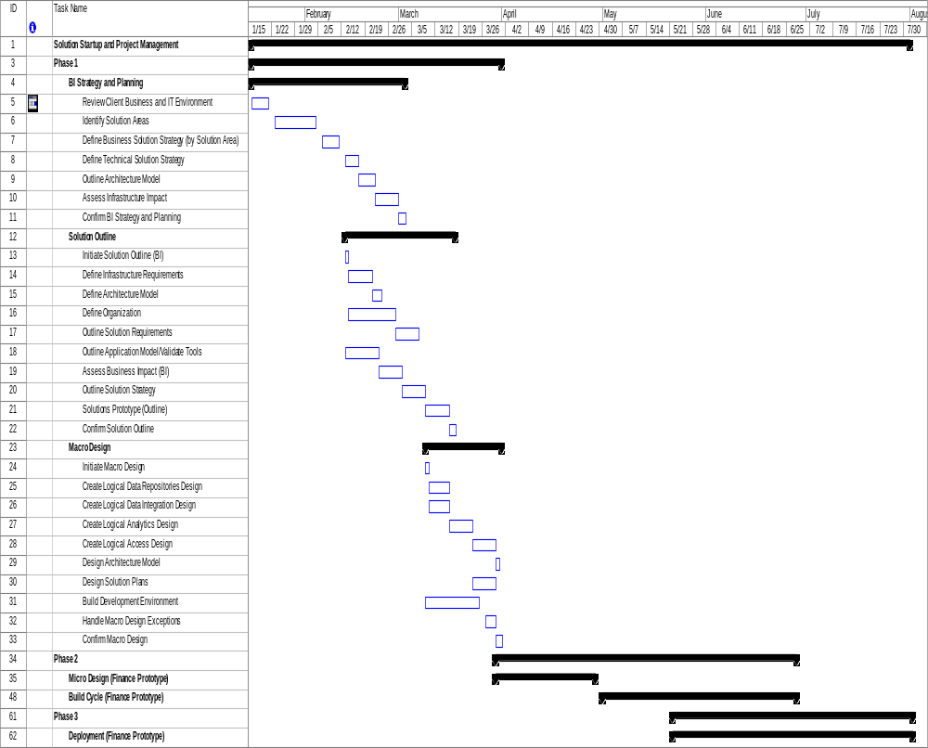

JCPenney Questions (RFI Section IV)
Describe the recommended methodology for tool selection, system definition, etc.
IBM Response: Our approach recommends use of IBM accelerators to provide a design and architecture that will be validated against JCPenney’s business requirements. Our approach eliminates the need for formal tool selection activities as we will utilize a validation approach to compare JCPenney’s requirements against our recommended tools and architecture. Activities to be performed as part of our tool validation approach include:
- Leading Practice Workshop
- Hold workshops with JCPenney SMEs to validate business requirements against RBIS
- Demonstrate functionality
- Hold workshop to demonstrate functionality of tools (ETL, OLAP) against leading practice tool selection criteria

Describe other engagements that the responder has completed with customers similar to JCPenney and the results of each. Provide names and numbers for a contact if these are reference able accounts.
IBM Response: We have provided references in both sections 1.4 and 8.1 of our response. We have provided contact numbers for the clients listed in section 1.4.

Responder should disclose all potential recommended vendors that responder has a relationship with (disclose the type of relationship).
IBM Response: IBM’s BI vendor alliances program is the most highly rated in the industry by both analyst firms and the vendors themselves. We have established relations with the leading BI vendors in the market. We have provided our existing vendor partnerships that may potentially relate to JCPenney Enterprise Information Architecture deployment
: 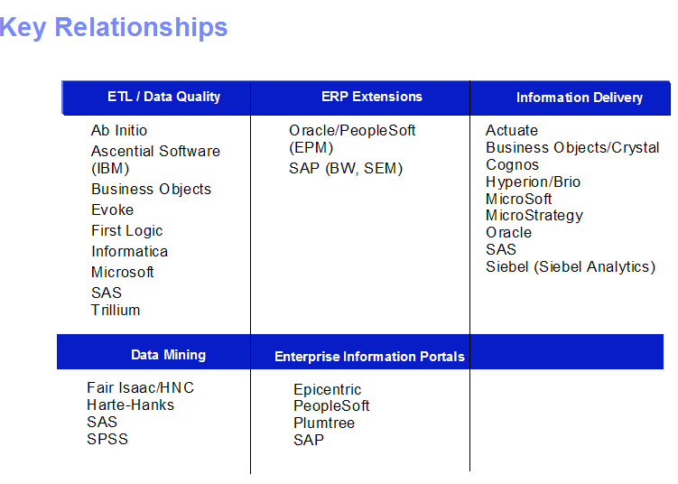

Responders should indicate that they are not receiving the compensation, monetary or otherwise, from the vendor that is recommended or included as a potential supplier in JCPenney’s project.
IBM Response: IBM does not receive compensation from our vendor partners.

JCPenney will retain the rights to all deliverables provided under this engagement. This license will include the right to publish results or provide results to third parties.
IBM Response: Please refer to the IBM Customer Agreement between JCPenney and IBM.

What differentiates your company from that of its competitors?
IBM Response: Please refer to Section 8.0 of our response for a summary of the IBM differentiators that we believe indicate we are the right partner to support JCPenney with this initiative. In addition, within sections 3 and 4 we have provided several examples of how we would approach implementing this initiative. Our approach, we believe, further differentiates us from our competitors.

Deliverables
Phase I deliverables will be produced which will document the business and information technology requirements, define the recommended EIA architecture and transition plan, document the business case for both the enhanced EIA and the Financial Reporting Prototype (consisting of the Financial Data Warehouse and Electronic Workplace), and document Data Governance strategies and plans.
The Phase I deliverables are summarized below:

Deliverable Name | Deliverable Description
- Detailed Project Plan | Activity and Task Level plan with resource assignments and schedule
- Business Intelligence Strategy and Roadmap | A comprehensive strategy document for establishing integrated Business Intelligence (BI) capabilities and vision, aligned with the business strategy. The strategy will incorporate elements from business strategy, organization, process, data, integrated performance measurement, and technology. The BI Strategy defines the needs, solutions, approaches, and value of an integrated BI environment. The roadmap is a high-level approach to incrementally implementing the BI capabilities, taking into account existing initiatives as well as new initiatives that are necessary to successfully support the business. The roadmap will help define individual projects to support the strategy.
- Business Case | A structured representation of the business value of delivering the EIA and the Financial Prototype, how benefits will be realized and what costs will be incurred.
- Business and IT Requirements Document | High Level requirements definition for a BI Solution Areas, and detailed definition for the Financial Prototype. This may include definition of performance measures, information delivery and data requirements, dashboards, reports, user population, etc.
- (EIA) Conceptual Data Model | A high-level (conceptual) data model outlining the information and data elements required to meet the business requirements from an analytics standpoint.
- Tool and Technology Selection | A document outlining the technical solution architecture for EIA. This deliverable contains the high-level logical design for each of the BI architecture “layers” in the solution, with the selected tools and technology for each layer and the requirements satisfied by each.
- Data Quality Strategy Document | A document outlining the strategy and approach for managing data quality as part of business intelligence solutions.
- IT Organizational Strategy Document | A high-level IT organizational strategy document which outlines the necessary steps to align the IT organization for developing and maintaining BI initiatives.
- Financial Prototype Deployment Plan | A plan outlining the tasks, resources and schedule necessary to complete Phase II Beta delivery and Phase III full deployment of the Financial Prototype.
- Weekly Status Reports | Project management reporting outlining progress, issues, risks, change management and plans for the next reporting cycle.
Between the deliverables and interim products summarized below, the deliverables identified in the JCPenney RFI will be addressed within our approach.

Deliverable | JCPenney RFI Deliverable/Requirement Addressed
Detailed Project Plan
Business Intelligence Strategy and Roadmap | - Provide a written report detailing the approach that would be required to meet the Phase 1 - Develop Enterprise Information Architecture Transition Plan.  - Map and analyze the current data warehouse and reporting process -- defining processes and scorecard measures - in order to define needed processes improvements and the appropriate transition plan.  - Provide a comparison of best of breed practices and processes and how they are being used by the industry.  - Develop procedures and processes to be used for future application in the development of data marts, OLAP, Reports and Dashboard for POC.
Business Case | - Provide Finalize Business case.  - Develop business cases for implementing reporting strategy with business case and assigned priority for each subject area.
Business and IT Requirements Document | - Determine subject area and requirements for proof of concept.  - Create system requirements to be used in an RFI and RFP to potential tool providers  - Capture reporting issues (definition, consistency, calculation, process, etc).  - Re-evaluate current KPI's, identify additional / modified KPI's and provide means to maintain KPI's.
(EIA) Conceptual Data Model | - Develop conceptual data models (measure, dimensions, views, etc).
Tool and Technology Selection | - Build a list of business and functional requirements that will be used for tool evaluation and a buy vs. build decision.  - Map information delivery requirements to software alternatives.  - Assistance in selection of software tools.  - Prepare a list of tools and features that are needed to meet requirements and how competition is using them. To be used in the evaluation and recommendation of tools.
Data Quality Strategy Document | - Provide data governance models (roles, expectations, process).
IT Organizational Strategy Document | - Provide data governance models (roles, expectations, process).  - Analyze current responsibilities by area and determine how these must be realigned to support the new process.
Financial Prototype Deployment Plan | - Develop detailed development plan for first implementation phases.  - Provide rollout strategy with timelines and readiness assessment.  - Provide plan for installation of test and production environment.
Weekly Status Reports

Interim Product | JCPenney RFI Deliverable/Requirement Addressed
Solution Definition and Roadmap  - High level definition of business solution areas which deliver EDW/BI capabilities, and the planned implementation sequencing | - Provide a written report detailing the approach that would be required to meet the Phase 1 - Develop Enterprise Information Architecture Transition Plan.
Technical Solution Strategy  - Technology components mapped to the BI Reference Architecture | - Prepare a list of tools and features that are needed to meet requirements and how competition is using them. To be used in the evaluation and recommendation of tools.
Logical ETL architecture  - Components of the Data Integration Layer and the planned integration between components | - Identify processes for capturing information, issues at capture point, and changes required to improve data integrity and timeline.  - Develop process improvement recommendation for improving information and data flow.
Logical source to target mapping  - Identification of source systems which will deliver Conceptual Data Model data | - Determine primary source of data for reporting analysis.  - Map reporting requirements to subject areas.
Source data quality assessment  - Quantification of the quality of data contained in source systems | - Determine primary source of data for reporting analysis.
Architecture document  - Overview of ETL Architecture, Portal Architecture and Portal Security Architecture and other technology components | - Map information delivery architecture to current applications.
Test Strategy document  - Definition of test environment and planned approach to testing | - Provide plan for installation of test and production environment.
Usability Requirements
- Defined usability preferences and disciplines
Metadata Strategy
- Tool approach for maintenance of data model and information processing statistics, and information traceability capability

IBM Differentiators

We believe that IBM is uniquely qualified to support JCPenney with the Enterprise Information Architecture (EIA) initiative. As requested by JCPenney, in the following sections we have provided additional information about our experience assisting other leading companies with similar initiatives, our commitment to providing retail industry specific solutions as well as our functional knowledge of finance and reporting processes required for the initial roll-out of the EIA.

Our Experience Implementing EIA Solutions
IBM has successfully completed several data warehousing initiatives for large complex clients similar to JCPenney. Below we have provided engagements that included the design, planning and transition to an Enterprise Information Architecture.
United Airlines
United Airlines chose IBM to design and build a powerful Enterprise Data Warehouse (EDW), which encompassed a customer relationship management (CRM) system, to position the airline to improve its customer service and increase operational efficiencies in the changing air transportation industry. The new CRM system – which will eventually manage more than 6 TB of operational and customer information data – uses Business Intelligence (BI) capabilities to identify trends in passenger flight destinations that can enable the airline to more efficiently coordinate and plan flight routes, increase efficiency in managing bookings, and enable one-on-one interactions across multiple CRM channels.
IBM has completed the first phase of the database design and build, including assisting United with extract, transformation (ETL) and load processing. This provides United access to integrated customer and operations data representing more than 1 TB of information leveraged from the reservation centers and United.com for use by thousands of United Airlines employees to better manage United’s customer accounts and improve operations and planning.

Blockbuster
Headquartered in Dallas, Texas, Blockbuster Inc. is a publicly traded subsidiary of Viacom Inc. with more than 8,000 stores throughout the Americas, Europe, Asia and Australia. Blockbuster stores carry a broad selection of movie titles for rent, which range from the hottest new releases to a library of older titles. Blockbuster is also the leading DVD renter, with the majority of the company's stores carrying hundreds of DVD units.
The company wanted to provide a new turnkey customer relationship management (CRM) solution in order to foster customer-centric marketing processes. It chose software applications from SAS and Unica to enable and enhance its direct marketing capabilities with IBM hardware for a reliable, scalable platform to support the CRM solution.
IBM Business Consulting Services (IBM BCS) professionals managed the implementation program and the company's CRM business process improvement to maximize the collection and use of Blockbuster’s customer information. In addition, a group of IBM BCS consultants advised in the technology components of the project, specifically the design and development of the 4.3 TB Operational Data Store (ODS) utilizing Acxiom.


E.I. Dupont
Over a 2 year period IBM has supported Dupont’s efforts to deploy an Enterprise Data Warehouse (EDW) to support the company’s strategic growth initiatives. The project included the initial design and implementation of an EDW architecture that could be leveraged for several phased roll-outs. IBM consultants designed and implemented the EDW architecture and developed the transition plan for Dupont’s two priority areas - Finance and Customer Sales.
The initial finance roll-out deployed a financial KPI dashboard reporting solution to monitor the performance of Dupont’s 25+ strategic business units. The second phase focused on deploying a single customer view of data to provide marketing function executives with customer sales data by product, region and business unit on a global basis. The architecture deployed utilizes a DB2 database, SAP data warehouse and IBM WebSphere portal solution. The effort included integration of over 20 source systems and a data cleansing process to aggregate customer data captured across the multiple source systems. The solution deployed with the help of IBM is currently providing Dupont executives with key insight into business performance.

Commitment to Providing Solutions for the Retail Industry
IBM has a long track record of success in first of a kind innovations and implementations. No company can better assist JCPenney in addressing their first of a kind challenges and risks than IBM. A few brief examples of this are:

- First of a kind IBM Research innovations such as advance modeling and analytics for customer segmentation & target marketing, retail promotion analytics and lane optimization

- IBM consistently sets worldwide records for new patents many that are directly related to solutions for the retail industry

- IBM is investing tens of millions of dollars in our Retail Emerging Business Opportunity which is focused on innovating the next generation of retail store business processes, store architecture and store solutions

- IBM, through our Global Retail Alliances is implementing new interoperability patterns using WebSphere tools to define opportunities for delivering retail web services capabilities to serve the needs of our joint strategic retail clients

- IBM’s Gaithersburg testing center regularly pushes the outer limits of performance testing and performance optimization for the world’s largest companies
In addition to these examples, IBM, through our Institute for Business Value, performs primary retail industry research to understand and analyze retail industry trends and directions and apply this knowledge to the development of new retail solutions. All together, IBM’s retail industry insights, retail industry business expertise, retail software and hardware solutions, research work and investments, retail software alliances, investments in new retail solutions and next generation retail architectures puts IBM in a position where we are leaders in defining the future industry agenda and the landscape for retail solutions. IBM leverages this position to provide strategic advice to our retail clients. It also affords the opportunity for us to invest in the joint development of new retail solutions or early implementations of these solutions with our strategic retail clients.

Some specific examples of services provided to the retail industry are as follows:

- Bill payment kiosks - Expedites bill payment for customers by using IBM kiosks that process cash, check, or credit cards

- Data center outsourcing services - Manages a customer’s data center

- E-Business hosting for the retail industry - Run and expand online retail activities rapidly and affordably

- Global expense reporting solutions - Transform and automate enterprise processes, enhance expense controls and maximize data visibility

- IBM On Demand Workplace for Retail - Furnish retail executives and associates with a personalized “dashboard” to increase efficiency of conducting business

Leadership in the Delivery of Business Intelligence Solutions
IBM is recognized as the largest and leading Business Intelligence Solution Integrator. IBM operates on all continents with Business Intelligence consultants in 25+ countries and over 2,300 skilled resources worldwide. IBM BCS Business Intelligence operates as a dedicated, global practice spanning each dimension of our IBM BCS organization.
Our BI services & solutions are centered on supporting the basic building blocks of planning, managing & optimizing the business. Our BI services & solutions are thorough including the vision, roadmap and blueprints for designing a fully integrated business intelligence environment, and approaches for maximizing enabling technologies and managing for success.

An Overview of Our BI Service Offering:
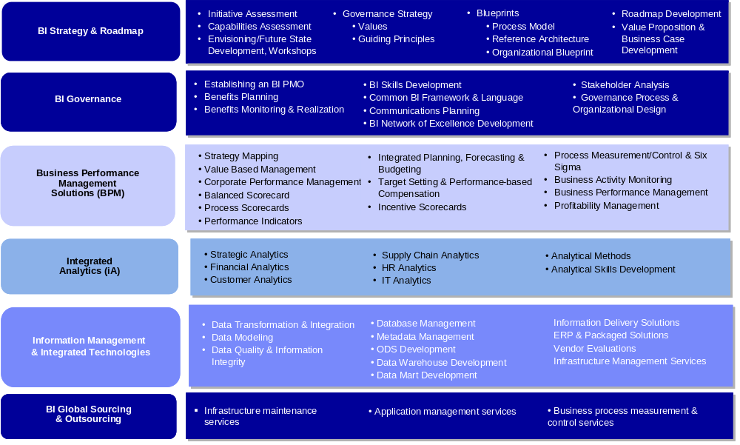

IBM is a worldwide recognized
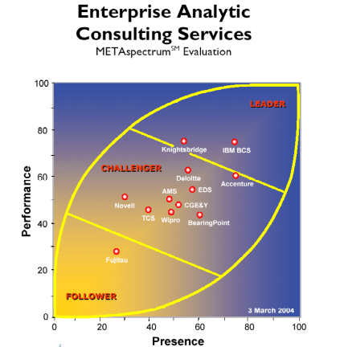
Leader in business intelligence
and data warehousing.

Numerous analyst reports,
Industry awards and product
Reviews attest to IBM’s
leadership in the BI space.

Today, IBM is ranked # 1 in
Business Intelligence and Data
Ware housing and continues to
Show significant growth. IBM’s
Hardware, Software and
Services revenue is now close
To 10 times greater than our
closest competitor.

In the most recently published independent survey conducted by the Meta Group, IBM BCS was recognized as the leader in the Enterprise Analytic Consulting Services METAspectrum.

Source: Survey.com market research report “BI and DW Competitive Analysis Report” at www.survey.com

In addition to this recent Meta Group publication, IBM has been recognized as the leader in the BI space by several other leading IT publications.

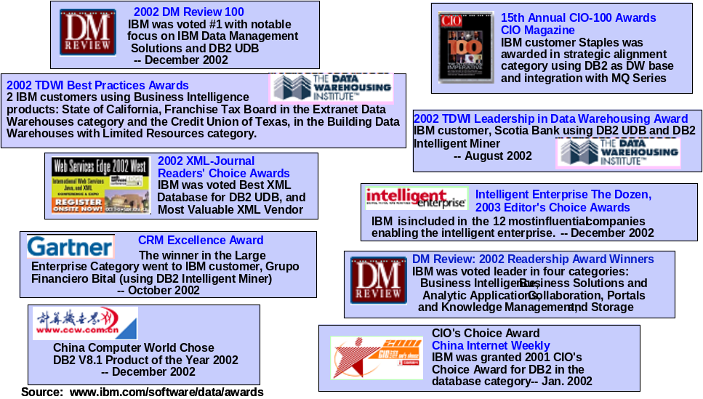

Our Knowledge of Finance
IBM Business Consulting Services capabilities also include a practice dedicated to providing services to the CFO and finance organization. Our Financial Management Services practice consists of over 5,000 consultants focused on delivering finance specific performance improvement services from development of finance transformation roadmaps to design and implementation of shared services centers to Sarbanes Oxley and focused financial process improvement.
An overview of the FM practice service offerings are provided in the diagram below:
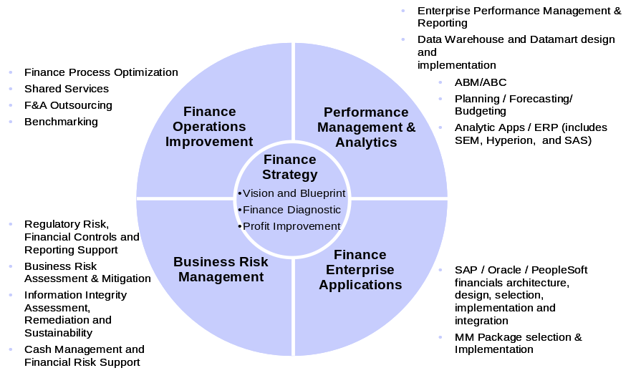

Dedicated to improving the efficiency and effectiveness of our client’s finance functions, the FMS practice helps CFOs transition from higher cost transaction focused organizations to a more nimble structure focused on providing valued decision support and analytics to the business. As the diagram below indicates most finance organizations today have successfully reduced cost and are now in the process of centralizing or outsourcing transaction processes while developing embedded decision support capabilities within business units.
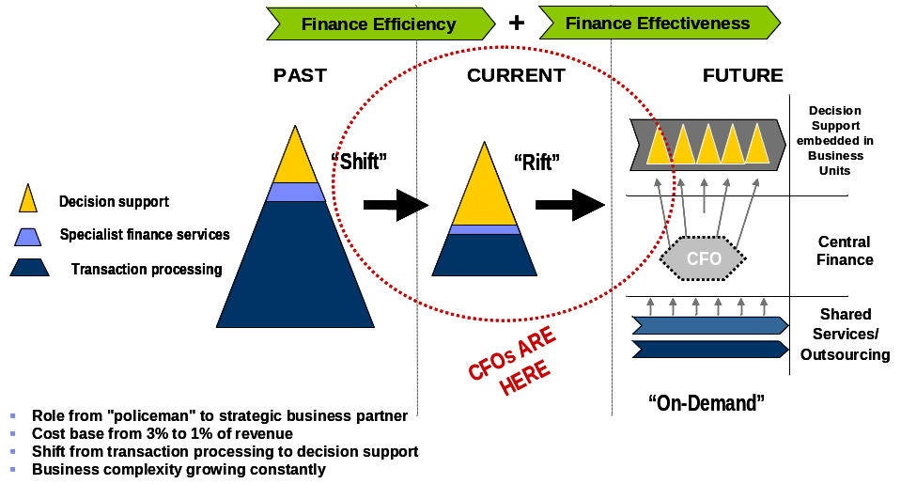

Our Experience Delivering Operating Cycle Time Improvements:

IBM Business Consulting Services has extensive experience delivering operational and cycle time improvement across each component of the supply chain. Below is a list of Retail industry clients and a description of the type of operational improvement services we have provided.

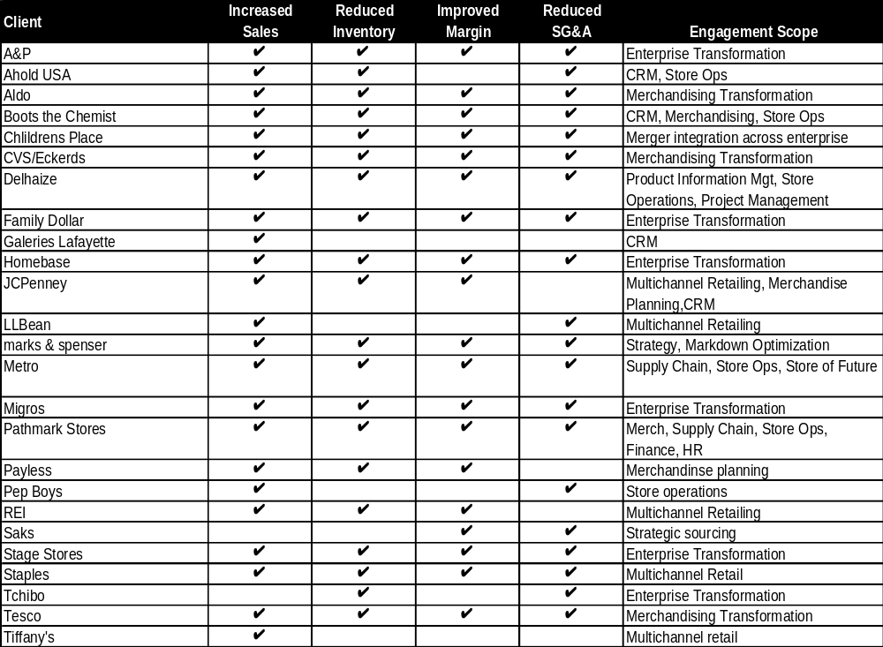

Overall Supply Chain Operational Cycle Time Improvement:

IBM has dedicated practice areas dedicated to designing and implementing performance improvement initiatives within several of the key operational areas mentioned in your RFI as noted below:
Our experience providing clients with solutions to improve supply chain processes including planning, merchandising, sourcing and inventory management is effectively articulated through the client case studies provided below:


A&P, United States
Overview
The Great Atlantic & Pacific Tea Company, Inc. (A&P) is a large regional U.S. grocery retailer. The company operates 633 stores and has 72,000 employees. A&P also serves as a wholesaler to 63 franchise stores in Canada
A&P was a company that was, for many years, leading the retail business practices and enabling technology. In the face of mounting competition, market share erosion and below average operating margins, A&P decided that a major transformation initiative of the retail and support functions in the company was required for the survival of the company. Specific high priorities included the need to consolidate purchasing to increase buying leverage with vendors, implementing a complete program to enable effective category management, forecasting and replenishment, and warehouse and transportation management. A&P also recognized that the transformation would require a major change to the organization and culture of the company. Partnering with IBM, A&P embarked on the EverGreen transformation project, to redefine its business processes, organizational structures, applications and technical infrastructure.
Project Scope
A&P and IBM created the business case for the enterprise transformation effort. We identified and quantified the opportunities for value creation, the risks associated with value realization and risk mitigation plans.
IBM led the strategy, design and implementation of Retek 10.0 merchandising, Oracle Financials, Oracle HR 11i, OMI warehouse management, Manugistics transportation management, and integrated these applications with multiple other point software solutions and several retained legacy applications.
IBM provided change management and technical infrastructure support throughout the project.
- The implementation strategy included a 36-month multi-phased approach. The program scope included the following key elements: Manugistics Freight Pay (audit bills), TM (Transport Manager), NetWORKS Carrier (web).
- Tactical merchandising initiatives to roll out new business processes for Assortment Rationalization and Customization, Pricing, and Promotion Analysis in order to achieve an immediate impact on the A&P organization through the use of third party data and other available tools.
- OMI’s TRICEPS (Warehouse Management System) at 11 A&P distribution campuses (Phased DC/Category rollout: Grocery and Fresh)
- Retek Merchandising (RMS) and Data Warehouse (RDW), implemented in 2002.
- Oracle General Ledger, Accounts Receivable, Accounts Payable, Purchasing, and Fixed Assets:
- Oracle HR, Benefits, and Payroll.
Implementation Highlights
Notable highlights pertaining to the project include:
- This project was first of a kind implementation. Retek software was selected as the retail system for A&P with the knowledge that significant joint development work was required to create a new version of the Retek software to support grocery specific capabilities. A&P, IBM and Retek designed and developed this new version of the Retek software and successfully implemented it.
- IBM led the business environment reviews, strategy validation work, business case development, tool selection, change management, process redesign, custom module requirements definition and overall project and program management.
- The processes and systems were implemented within budget. Some delivery dates shifted due to software vendor delivery issues. Within these revised schedules the projects were delivered by IBM on time. Knowledge transfer was complete within 1.5 years.
- A critical success factor of the transformation was the contractual partnership commitments between A&P, IBM and Retek that were established at the beginning of the project. These agreements kept the parties focused on resolving issues and joint success during difficult challenges faced throughout the project. IBM and Retek made direct incremental financial investments into the success of the transformation based on these agreements.
- IBM identified a portfolio and plan of new short term initiatives and acceleration of other parts of the transformation program that delivered over $70 million in benefits to close gaps created by software vendor delays in delivering new software, to effectively realize the planned business case benefits
Benefits Realized
Project EverGreen provided and entirely new foundation of enterprise processes and systems to operate the company more effectively and efficiently, assisting A&P in remaining competitive in a challenging retail market segment.
New capabilities provided visibility and efficiencies across A&P’s entire supply chain. Category Management processes were drastically improved, which resulted in merchandising efficiencies and provided a foundation for both strategic and tactical decisions-making.
A&P has realized many benefits that they attribute to their transformation project, including:
- $240M in inventory savings over 4 years, and increased pretax profits by $74M annually
- Increased sales from improved in-stock positions, and improved customer satisfaction
- More effective pricing and promotion planning and execution
- Dramatically improved visibility to product and customer information
- Improved decision-making abilities

 BP, United Kingdom & United States
Overview
BP p.l.c. is the holding company of one of the world's largest global petroleum and petrochemicals groups.
IBM and BP have had a long and successful business relationship, in which IBM has supported BP on many of its transformational initiatives across many of BP’s business units. The BP Connect program focused on BP's global network of filling stations and convenience stores, and the implementation of SAP Retail.
BP embarked on this project as part of their global project to implement Retail best practice providing “transparency and control” within in its organization including audit trails and one version of the truth. It also aimed to implement advanced category planning and rules based pricing, which its current system did not support. Streamlining business processes and implementing best practices across all geographies and markets would deliver bottom line value to BP. Further, by eliminating duplicate activities, and facilitating working globally – the organization would enable better management decisions, deliver better customer service and reduce overall SG&A costs.
Project Scope
The BP project included the implementation of SAP Retail 4.7, SAP FI/CO 4.7, SAP BW. IBM led the effort to build a global template design and the following roll out strategy.
Stage 1 “Reporting” IBM implemented standardized data and a new global product categorization. This included building an interface from the store's POS to SAP BW and a link to master data within SAP.
Stage 2 “Merchandising” Implemented retailing merchandising processes representing industry best practices, supported by SAP Retail. This included POS inbound and outbound to stores and the management of item level inventory.
Stage 3 “Retail Finance” Implement fully integrated Retail Finance Operations using cost accounting on a single integrated SAP platform. SAP Retail 4.7 SAP FI/CO 4.7 and SAP BW.
The reason for the early deployment of SAP BW was to gain a quick win with operational reporting. In addition, IBM led the design/blueprint for its initial markets to confirm the global template and variations by market. The systems were rolled out in three phases over 12 months to 3 countries (US, UK, NL).
Implementation Highlights
Notable highlights pertaining to the project include:
- IBM maximized international development to manage project costs. This project successfully implemented the use of a near shore / off-shoring resourcing to support both development and the functional configuration of the SAP system.
- The initial implementation was for BP’s ‘Accelerator’ markets (650 sites in the UK and USA). Proof of concept for the Retail and BW solution was verified in a conference room pilot that was completed in July 2003.
Benefits Realized
BP realized business benefits in the following merchandising areas: product, pricing/price book, category management, rebates, promotions, planning promotions, trade funds management, waste management, range and space planning, product sourcing, price optimization, and store replenishment. BP also realized significant benefits in reduced costs associated with retired legacy business applications.

Homebase, United Kingdom
Overview
Homebase is the second largest DIY retailer in the UK, with sales of $2 billion. It was sold by Sainsbury’s to a Venture Capital firm in 2001 and then to GUS in 2003. It runs approx 350 stores with focus on the softer end of DIY, with gardening, furniture and interior decoration being strong sellers.
In 2000, Homebase was faced with both internal and external pressures to evaluate its business processes, organizations and systems. Homebase legacy systems were predominantly developed in-house over a 20-year period, were unreliable and delivering poor customer service. Homebase had low availability of product in the store, and little visibility of supply chain inventory. Its in-store processes were poorly supported by information and were very labor intensive.
Homebase determined there were significant benefit opportunities by designing and implementing new processes, specifically around forecasting, ordering and stock control. They required a platform that was open and flexible to accommodate the current business strategy to grow in areas of: New Format, E-Commerce and Catalogue. Further, Homebase determined new processes and systems would provide the strategic platform for the future development of the business. To further solidify the plan, Homebase was faced with a requirement to migrate off Sainsbury’s mainframe systems following the sale of the business. Homebase embarked on an enterprise transformation initiative, led by IBM and enabled by SAP Retail business applications.
Project Scope
IBM led the implementation that redesigned the store, supply chain and head office processes, with greater automation and visibility of information. The business process scope included: sourcing, ranging & merchandising, forecasting & replenishment, pricing & promotions, distribution, inventory management and management reporting. Homebase used IBM software to manage POS with near real-time data feeds. The project also included replacement of the store POS equipment.
IBM supported Homebase through the Blueprint and Implementation phases of a business process reengineering. The Blueprint and Build were completed in Spring 2001 followed by Integration Testing, Stress & Volume Testing, Data Conversion, Training and Go Live Preparation. The roll-out for Phase I was split into Head Office and the 5 distribution centers first, followed by the roll-out of 275 stores. A large number of complex enhancements were required to meet Homebase’s business requirements, such as a procurement solution for Horticulture. IBM worked closely with Homebase to facilitate the proper design and implementation of these capabilities.
Integration was also required for up- and downstream systems such as POS, an external warehouse management system (Catalyst), a forecasting and replenishment system (Inforem), a separate financial system (Oracle Financials) and a legacy demand forecasting system. RF technology was also implemented for the in-store solution.
Implementation Highlights
Notable highlights pertaining to the project include:
- IBM led an effort to address the significant business process changes required with respect to the central replenishment strategy, and developed the governance structures for master data maintenance and stock accuracy;
- IBM successfully delivered results throughout the project life cycle, including responding to changing business objectives, scope and strategies as a result of two ownership changes – from public to investment capital private equity, back to being a subsidiary of public company – midway through the project.
- IBM worked with Homebase to develop a 2-phase rollout approach that reduced the risk of a Big Bang approach.
- This was one of the first SAP Retail implementations to utilize SAP Business Warehouse for Retail – and one of the first SAP Version 4.6 implementations.
- IBM successfully transferred knowledge and skills to Homebase staff, and the store rollouts were managed internally.

Benefits Realized
Homebase achieved its return on investment objectives for the project. Homebase improved working capital, reduced store labor & administration costs, reduced target inventories and improved overall product availability. This translated into increased sales, higher margins and profitability. And equally as important, IBM successfully migrated Homebase from the Saintsbury legacy systems without loss of business continuity.
Product Life Cycle Management:
In addition to our experience improving Supply Chain processes, our Supply Chain practice is currently assisting several clients with product design and development initiatives and operational improvement of manufacturing processes. Through this experience we are finding that due to aggressive market forces many retailers have begun to examine product lifecycle management options. Some of the value that IBM is bringing to these clients is a proven approach to new product development as depicted in the diagram below.
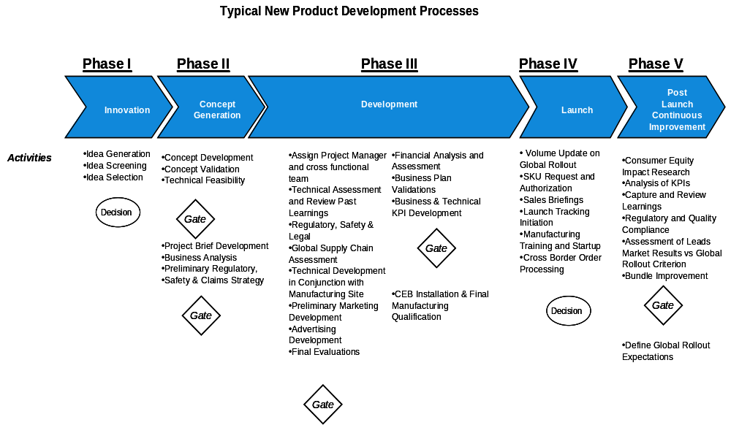

Our experience delivering results in this area indicates that many of the processes inherent within product development and manufacturing process are disconnected and supported by isolated systems which contain numerous aspects of the end product but are often un-versioned or incomplete resulting in poor, time cost and quality performance. The diagram below developed from our experience in this area articulates this challenge.

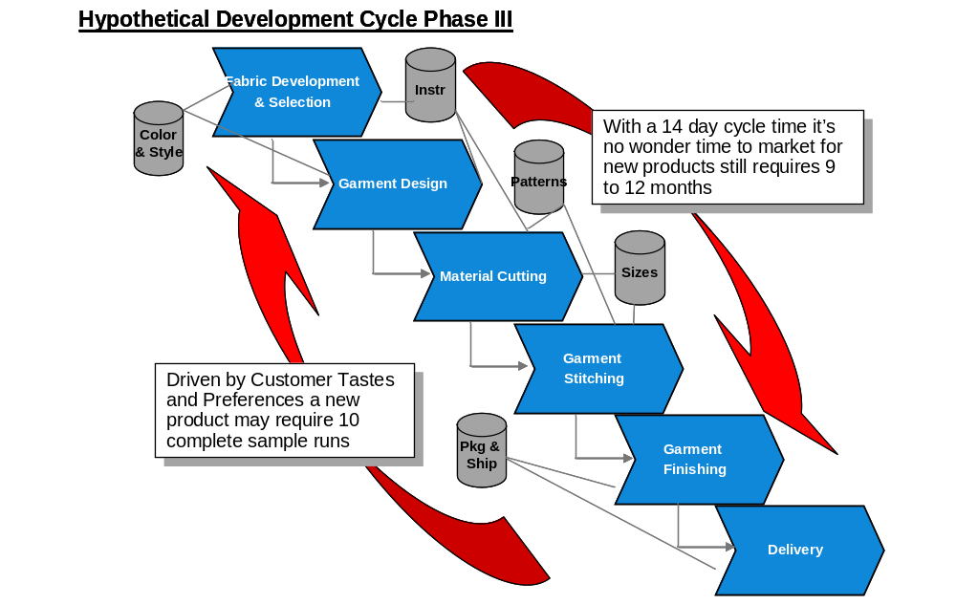

During the project implementation, IBM will be able to provide JCPenney with additional information on our experience in these areas.

Pricing, Project Assumptions, and Resource Plan

Project Pricing
Below we have provided our pricing estimate for all three phases of the project.
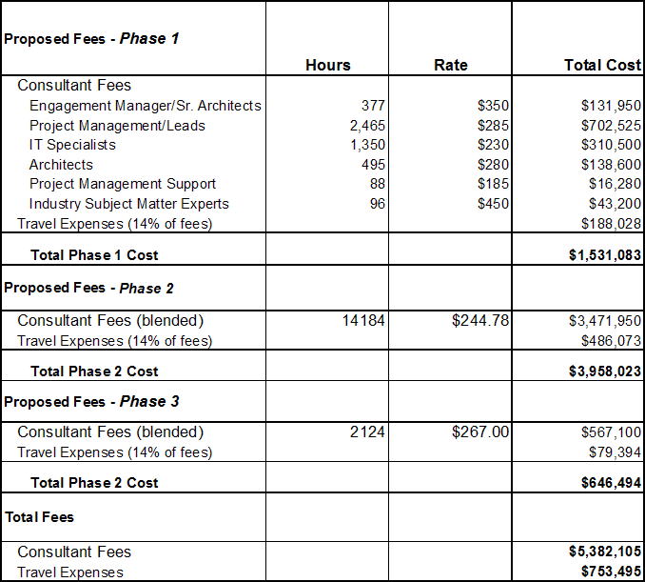
Responder should address the following pricing issues as well: Travel expenses will be capped at a percentage of fees. Responders may propose a cap.
IBM will add a 14% fee for travel applied to professional fees.
This engagement will be either a fixed fee or time and material not to exceed. Indicate a preference for one of these options.
IBM is open to either.
The successful responder will be paid on a milestone basis following acceptance of each milestone by JCPenney. Please propose a milestone schedule that is tied to deliverables specific to this project.

Proposed Milestone Based Payment Schedule
As part of our milestone based payment schedule, each monthly invoice will be reduced by 10.0% of the dollar amount attributable to Services as a holdback. This holdback will be payable on completion of the appropriate milestone. This milestone schedule will be based on completion of the following project deliverables:
• Detailed project plan
• Business intelligence strategy and roadmap
• Business case
• Business and IT requirements document
• (EIA) conceptual data model
• Tool and technology selection
• Data quality strategy document
• IT organizational strategy document
• Financial prototype deployment plan
• Weekly status reports

Project Assumptions
Pricing Assumptions:
Project management:
- Phase 2 will overlap with Phase 1 by 1 month
- Common reports only will be implemented. Up to 25 common reports will be implemented by "roll-out" in phase 3. A maximum of 5 reports for beta users will be developed during phase 2
- Of the 25 common reports, 20% complex, 40% medium, 40% simple
- One dashboard with up to 10 KPIs for finance will be available for rollout in phase 3, up to 6 for beta users at end of phase 2, and up to 2-3 KPIs for prototype during phase 2
- Data is for just finance initially
- Up to 10 beta users in phase 2, up to 50 users for the roll-out in phase 3
- The finance data needed to support phase 2 implementation will be up to 1 TB of data in the data warehouse and datamart components.
- Up to 25 interviews will be conducted during strategy and planning. Up to 2 workshops will be conducted during strategy and planning.
- Our pricing estimates are based on the proposed IBM architecture and recommended approach outlined in our response
Infrastructure:
- Includes up to 2 interfaces between analytic Information Services Layer and WebSphere Portal Server using MQSeries
- Assumes messages from analytic tools are XML based using standard protocols and will require no translation or mapping just transport management between Information Services Layer and Access Layer
- Tools perform in a J2EE environment and run on IBM app servers with available standard API's.
- Tools have web services capabilities that can be leveraged, if required
- No new interfaces in Phase 3
- Prototype will be one interface to an analytic tool namely MicroStrategy or AlphaBlox.
- AlphaBlox and MicroStrategy will support the financial reporting needs for in scope common reports
- WebSphere portal server is the portal delivery mechanism
- MQSeries is assumed as the transport mechanism for enterprise integration
Portal:
- Architecture: Standards – Portal will be implemented using the following standards: Java, J2EE, JSR-168, WSRP, Struts, JavaServer Faces, JSPs, HTML, XML, and EJB
- Configuration Management: Repository – Assume that a CVS repository (or similar repository) is available.
- Deployment Environment: Portal/Portlets artifacts deployed to development, acceptance test, and production environments
- Phase two:
  - Assumed that DB2 AlphaBlox FastForward is installed in the same WAS instance as WebSphere Portal Sever.
  - Assumed that there is no custom portlet development.
  - Assumed that portal access to MicroStrategy and IBM DB2 AlphaBlox is through IFrame portlets or links.
Project Assumptions:
- The first subject area to be added to new architecture and framework is Finance
- JCPenney personnel will install the SW and HW components required for the solution.
- JCPenney will obtain SW licenses for the tools needed to implement this solution (Retail Data Model (RDW), Required RBIS components, Datastage, Qualitystage, Profilestage, Metastage, AlphaBlox, MicroStrategy, WebSphere portal)
- JCPenney Application managers will test functionality of products/tools
- There will be up to 6 source systems used to feed the data warehouse for Financial reporting and KPIs for ph 2. (Only the ones needed to support the 25 reports/KPI’s selected)
- There will be up to 10 individual interfaces (ETL processes) for those 6 source systems for ph 2.
- JCPenney will be responsible for providing extracts from the source systems to the delivery team based on detail specifications
- Data cleansing in JCPenney source systems and data conversion activities will be the responsibility of JCPenney resources
- The Strategy and Roadmap components will run a parallel path with the “Requirements/Design common for financial reporting” in ph 1.
- Project Phase 1: Develop Enterprise Information Architecture Transition Plan with software recommendations. No prototype dashboard.
- Project Phase 2: Implement initial Financial Reports to new Dashboard within the new infrastructure (beta users). Portal integration with BI engines via IFrame portlets or links.

IBM Resources and Role Descriptions
Engagement manager: Responsible for the overall delivery of the project and the relationship with the JCPenney project sponsor.
Project Manager: Responsible for the delivery of the project and the day-to-day interface with the delivery team and the JCPenney project manager.
Business Analyst: Business requirements gathering for the finance reporting. Assist process lead with analyses. Interface with the business areas.
Business Process Lead: Review current financial reporting processes and business requirements. Identify process improvement opportunities. Ensure business requirements are integrated into BI solution. Recommend process changes. Assist with roll-out of new processes to finance community. Support the business case development.
SOI/EAI Lead - Enterprise Application Integration lead who will be responsible for design, development, and deployment of the integration architecture model and components. Focus will be on the messaging interface between the information services layer and the electronic workplace and other business user touchpoints.
SOA SME - SOA subject matter expert that will help guide the SOI/EAI Lead during the project on the feasibility, approach, and modeling of services oriented integration. The SME will be responsible for the high level assessment of the services oriented integration model with the overall application integration framework.
Portal Architect: Portal architecture and portal configuration
Portal leadership: Portal Installation / Deployment Specialist, Installation of portal environments (WebSphere Application Server, WebSphere Portal Server, LDAP, HTTP Servers, etc), Basic configuration of portal environments., Development of portal themes and skins for custom 'look' and 'feel'., Deployment of portal development artifacts
BI Data Modeler: Data modeler with specific skills in the field of decision support/BI data modeling constructs. Solid understanding of business context and terms.
BI Strategist: Experienced BI professional with IT architecture skills and business subject matter expertise. Converts business vision or strategy into actionable BI strategy
Infrastructure Architect: IT professional with an appreciation of business content and BI architectural considerations.
Usability Engineer: A human factors or usability engineering professional who applies user centered design (UCD) principles to provide guidance and expertise for developing solutions and producing work product deliverables to confirm that they are usable and productive.

Project Resource Organizational Diagram
Below is the suggested project organizational structure. Engagement team resources named in this proposal will be held for this engagement through January 15, 2006. IBM may have to substitute similar resources if an agreement between IBM and JCPenney is not reached by January 15, 2006.
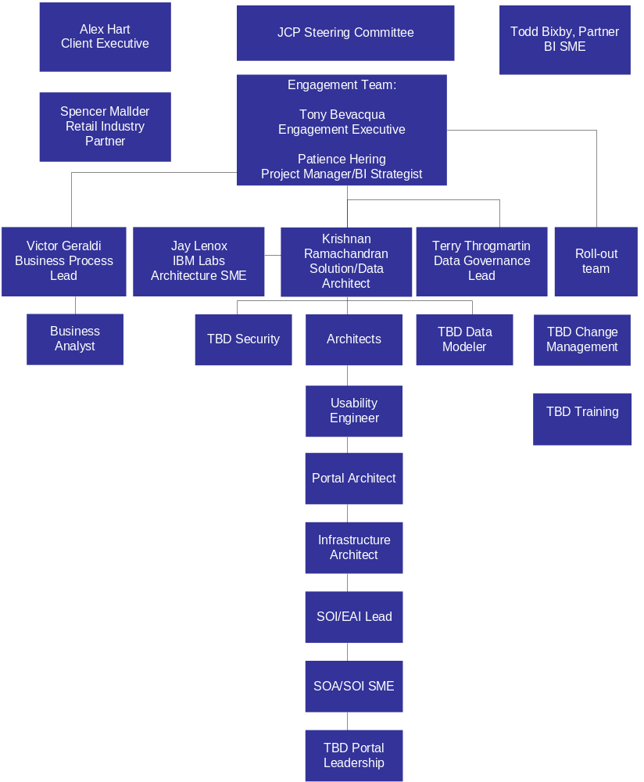

JCPenney Resource Requirements
IBM requires the following JCPenney resources for the duration of the project:
Project Manager (full-time)
Project Sponsor (one day/week)
Business Area SMEs (Finance, HR, Multi-channel, Speed) (1 per functional area 50% of time)
IT Business functional area expertise (Finance, HR, Mutli-channel), (1 per functional area, 50% of time) with one full time lead with knowledge of the data sources for current financial reporting
Technical resources to install software/hardware as needed, (full-time until software/hardware is installed and 25% of time after installation for problem resolution)
DB2 DBA (one day/week to run record counts/reports, etc)
ETL personnel (one day/week to run record counts/reports, etc)
Unix system administrator (full time initially during installs, 50% after installs completed)

Team Member Resumes
Tony Bevacqua
Project role: Engagement Executive
Tony is an Associate Partner in the Financial Management (FM) practice area within IBM Business Consulting Services. The FM practice provides finance strategy, performance management, finance application implementation, finance operations and business risk management services. With over 15 years of combined industry and consulting experience improving finance function performance across multiple industries, Tony has worked with several Fortune 500 finance organizations as both an internal manager and consultant. Experience includes
- Management positions within the financial planning and controller functions for a global pharmaceutical company (prior to consulting)
- Project Manager positions for global finance transformation and business intelligence client service engagements with overall client relationship and project delivery responsibilities
- Leadership positions and practice building responsibilities within the finance transformation practice
Tony has led complex engagements focused on finance process redesign, decision support system implementation and strategic cost analysis. His experience includes managing projects with over 50 resources and several international assignments. Tony’s recent focus includes project management responsibility for global Performance Management and Business Intelligence implementations. He is one of our lead consultants responsible for developing and improving our current business intelligence and performance management services.

Employer History
Feb. 1995 - Present, IBM Business Consulting Services, Managing Consultant
Dec. 1990 – Feb. 1995, Global Pharmaceutical Company, Management positions in Finance and Accounting
Tony held various positions responsible for accounting operations, capital budgeting and financial reporting. Tony implemented a cost control process to support the financial management and assessment of long-term multi-million dollar development projects.
Dec. 1989 – Dec. 1990, Environmental Services Company, Assistant Controller
Tony managed the accounting function for the contracting division and was responsible for general ledger, budgeting, working capital management and reporting. Tony reduced working capital days outstanding for the division from 5 months to 3.5, resulting in over $100,000 in savings annually and a 42% increase in the division’s return on assets.

Assignment History
Project Manager for Global B.I. implementation of Financial and Sales Dashboard Reporting Solution
Project manager position for an engagement tasked to provide dashboard reporting to senior executives of a $25 billion global chemical company. This business intelligence initiative includes the implementation of Business Warehouse and IBM’s WebSphere portal to provide web based reporting of key financial metrics. The overall scope of the project required integration of approximately 25 source systems and data cleansing capabilities to match and aggregate customer master data to enable global customer sales reporting. The project’s initial phase went live in April 04 and the final phase was completed in Sept 05.
Project Manager for Performance Management Process Redesign
Project manager position for the redesign and implementation of new performance management processes for an $8 billion global manufacturer of railway equipment – an initiative intended to provide the initial thrust for a longer term finance transformation effort. Overall responsibility for developing the implementation strategy and managing the rollout of an integrated reporting solution that collected legal and management information from over 60 separate entities worldwide to support global management reporting for over 600 users. Tony led an international team consisting of 60 team members (25 consultants). Project included implementation of a new planning system to support the forecasting process, global consolidation process (legal and management) using SEM-BCS and migration of all reported data to a single data warehouse reporting system. In addition, new forecasting processes were developed and integrated into the client’s overall performance management model. The project was completed in ten months with a successful go live in July 03.
Project Manager for analysis of reporting systems at a global pharmaceutical company
Managed an initiative focused on evaluation of decision support processes and software applications for a $12 billion pharmaceutical company. Recommended decision support process improvements and the common decision support tool. Applications evaluated included Hyperion’s Essbase, Applix’s TM1 and SAP’s SEM solution.
Project Manager for process reengineering initiative
Redesigned financial processes for a multi-billion dollar energy client. This engagement, part of an overall restructuring of the finance organization, included assessment and redesign of the month end financial close process with a focus on identifying and correcting internal control deficiencies. Role included leading the initial process reengineering and developing a phased implementation strategy. Advised the client through the initial phase of the implementation by developing a framework to integrate best practice internal controls, policies and procedures into the redesigned process.

Education and Background

- MBA, Financial Management, Drexel University, Philadelphia, Pennsylvania
- BS, Accounting, Widener University, Chester, Pennsylvania
Todd Bixby
Project role: BI SME
Todd Bixby is a partner in the Business Consulting Services leading Business Intelligence for Retail. He is a seasoned professional with eighteen-plus years of leadership in Business Intelligence and Analytics. He specializes in process improvement and automated solutions that help build and measure customer intimacy, drive sales and marketing effectiveness and provide enhanced business knowledge through the use of advanced integrated knowledge and analytic delivery techniques. He has a comprehensive background in designing and delivering large-scale Information Delivery Environments. Mr. Bixby has specific knowledge in the development of Business Intelligence, analytic, campaign management, decision support, forecasting and data warehousing solutions leveraging leading technologies.

Employer History
September, 2005 – Present, IBM Global Services, Partner
Mr. Bixby is responsible for delivery of retail business intelligence solutions.
November 1995 – June 2005, BearingPoint, Managing Director
Mr. Bixby was responsible for starting the data warehouse and business intelligence practice that included development of the first comprehensive data warehouse methodology. He then led the Consumer segment CRM and Business Intelligence practice. He led specific projects in CPG, manufacturing and retail. He was responsible for defining and managing key alliance relationships for BearingPoint.
May 1993 – November 1995, BSG Consulting, Manager
Mr. Bixby started the data warehousing practice and led the implementation of a real-time sales and inventory portal for a large leisure services company.
March 1991 – May 1993, Information Advantage, Manager
Mr. Bixby led the design, development and implementation of a sales forecasting system for Coca-Cola. Algorithms were then embedded in standard software offering. Developed first sales reporting dashboard and data warehouse for Tupperware, which became the standard software front-end (Briefing Book) for the Information Advantage product suite.
Assignment History
- Delivered an Integrated Marketing Solution including email campaign management solution for large medical device organization.
- Delivered Strategy and Design of a global Business Intelligence Environment including OLAP, Data Warehouse, Data Standards, Business Measures and Data Quality solutions for a large Quick Service Restaurant Chain.
- Delivered a Businesss Intelligence Strategy, Roadmap and Pilot epiphany project for a large Coffee Retailer.
- Managed the delivery of a large scale Financial and Customer information delivery environment for a Fortune 3 automotive/truck manufacturer.
- Managed the delivery of multiple large-scale Internet strategy projects that included customer management approaches as well as possible business spin-offs.
- For large consulting organization, National Alliance Managing Director for e.piphany.
- Managed the delivery of a web enabled integrated data warehouse/ERP solution focusing on costing for a large glass manufacturer.
- Managed the delivery of a web enabled customer information environment, including sales and marketing information, for a large lighting manufacturer.
- Responsible for the delivery of numerous large scale internet-enabled data warehouse projects across multiple industries.
- Responsible for overall data warehouse technical architecture and information delivery process and design for the National Institutes of Health.
- Responsible for the development and implementation of standardized Data Warehousing, Knowledge Management and information delivery Methodology for large consulting organization, The Methodology for an Integrated Knowledge Environment (MIKE).
- Developed and delivered a Rapid Conversion and Implementation project for a major retail rental company that was growing by acquisition and needed an expedited approach to on-board all of their acquisitions in an expedited manner and convert to a single instance of ERP.
- Lead the initiative for BearingPoint to gain a core competency in data warehousing. This included the review and evaluation of data access tools such as query tools, OLAP multidimensional database technology, and web access tools.
- Project manager for a team of developers and analysts responsible for the delivery of an integrated Decision Support System for a major Leisure Services Company. This system included integrating multiple distributed data sources, forecasting, ad hoc and exception reporting.
- Responsible for software vendor evaluation, selection and negotiation as part of a national data warehousing lab environment and alliance strategy.
- Designed databases and directed application design and development for multiple installations of client/server applications including: data warehouses, EIS, DSS and forecasting systems.
- Lead database design effort and played integral role in developing the user interface for an integrated sales information system for a major packaged food company.
- Played an integral role in defining EIS/DSS and Forecasting systems and processes for a major soft drink company.
- Lead designer and project manager for a client/server Demand Forecasting System and Sales Forecasting System developed for major pharmaceutical company.
- Developed multiple client/server forecasting systems for fortune 500 clients in the pharmaceutical, consumer products, retail and leisure services industries. This included defining, developing and applying statistical algorithms and methodologies to create and distribute semi-automated weekly forecast detail.

Education and Background
- MS in Biostatistics from University of Minnesota
- BS in Mathematics from Creighton University

Patience Hering
Project role: Project Manager
Ms. Hering is a managing consultant in the IBM Global Services Business Intelligence Consulting and Services practice with more than twenty years of experience in Customer Intelligence, Customer Relationship Management (CRM), web development, database development and data warehousing. She recently has concentrated on the design and development of large multi-faceted enterprise data warehouse solutions as well as e-business on demand (ebod) and Business Intelligence (BI) offerings. Ms. Hering specializes in innovative uses of web and database technologies to solve executive-level problems. She has managed multi-million dollar engagements in the education, airline, health care, banking, manufacturing, government, chemical, distribution and retail industries in the United States and London.

Ms. Hering is proficient in the use of Oracle, DB2 and the IBM Business Intelligence Method. She has managed e/BI projects in which IBM was the Application Service Provider (ASP). She has experience with 3-tier applications consisting of client workstations, the web and a database server. Ms. Hering has gathered and documented requirements frequently for web and data warehouse projects. She has implemented appropriate data cleansing procedures, designed naming conventions and standards, formulated database administration daily procedures and guidelines and modeled a backup and recovery strategy for the corporations in which she was employed. Ms. Hering has excellent communication and leadership skills, enabling her to lead large IBM/client teams of technical professionals and business users.

Employer History
March 1998 – Present, IBM Global Services - Managing Consultant, Project Executive, Solution Architect, Project Manager, Business Intelligence Strategist
Held multiple roles and been a member of numerous projects since joining IBM in 1998. Recently led the design and implementation of an enterprise data warehouse using SAP BW for one of the largest tobacco companies in the world. The solution enabled the company’s sales force to make better business decisions based on sales volume and product brand.
September 1996 – March 1998, Blockbuster Entertainment, Data Warehouse Manager
Led the implementation of Blockbuster’s first enterprise data warehouse containing customer, product, and point-of-sale information. A national restocking performed using the data in the data warehouse was estimated to have increased corporate revenue by six (6) percent or $378 million.
Other employers include Sara Lee / Champion, Wachovia Bank, USAirways, and GTE Government Systems.

Assignment History
- Project Executive/Business Intelligence Strategist – Led the development of an enterprise data warehouse focusing on sales and products for one of the largest tobacco companies in the world. Responsible for the overall technical design and management of the project team and client relationship. The initial implementation of the project included a Sales-focused application regarding volume data. The Sales application provided business value by creating a central repository for volume information for the business functions (Sales, Marketing, Finance, Operations) to view based on their particular hierarchy. The volume data had integrity and provided a consistent view of the information across the enterprise. SAP BW 3.1C and Oracle was used for the Information Factory running on UNIX. In addition, led the team that evaluated and selected the components and toolset to use in the Information Factory. These components/toolset included but were not limited to: OLAP, data mining, query, reporting, Extract, Transform, Load (ETL), Web portal, security and wireless notification. Started on the project during its initial Business Discovery phase in 2003; completed the delivery of the data warehouse in Jul 2004 and the dashboard GUI front end for Sales in Mar 2005.

- Solution Architect – Responsible for the architecture of an e/BI application for one of the world’s largest airlines. The new application was a thorough rewrite of a legacy system and targeted the airline’s top one percent customers. The front-end consisted of an interactive web application and the back end consisted of an Operational Data Store and a Reporting Data Mart. Oracle was the database management system utilized on a SUN/Solaris hardware platform. The application was targeted to increase revenue by several million dollars.

- Team Lead - Contributed to the business analysis and design of a procurement/strategic sourcing data mart for a $10 billion food distribution company. Participated in JAD sessions with the user community and produced design documents that supported the findings of the team.

- Project Manager - Led the implementation of a two-terabyte operational data store (ODS) for a $6 billion chemical company. The information in the ODS was to be used to populate data marts and to provide a location for adhoc and canned reporting. The ODS was produced from a SAP source system and (once in place) enabled users to no longer interfere with the operational production system when executing reports.

- Data Warehouse Manager – Blockbuster Entertainment. Led the implementation of a 4.2-terabyte data warehouse to provide information on over 3,700 stores for the marketing and product planning departments. Managed a development team for Blockbuster of up to 30 persons including Blockbuster and non-Blockbuster personnel. The team consisted of technical and business persons including Vice Presidents. Implemented a Data warehouse housing several million-row tables and utilizing a massively parallel machine (IBM SP) and Oracle Parallel Server v7.3. Information from the data warehouse enabled "smarter" buying, which resulted in higher revenue per store and enabled the retailer to design direct marketing programs based on customer demographics.

Education and Background

- MBA, Northeastern University
- BS in Computer Science from Baylor University
- Certified Consultant

Victor Geraldi
Project role: Business Process Lead
Victor T. Geraldi is a Senior Consultant in the Financial Management Solutions Practice Area within BCS.
Victor has over fourteen years of Management Consulting experience working with executive level managers in the development and implementation of operational and strategic change initiatives. Majority of client work has been in large-scale, ERP driven, enterprise wide change initiatives. Primary focus has been implementing process improvement, organizational change and shared services initiatives within Fortune 500 Companies. Strong analytical, organizational and project management skills. Familiarity with numerous systems packages and strong PC skills.
Employer History
September 1996 – Present, PWCC/IBM, Principal/Senior Consultant
July 1989 – May 1994, Major Consulting Organization, Consultant
Assignment History
- For a global Electronics Company was the Project Manager for a Shared Services Strategy, Design and Implementation project. Responsible for all aspects of project development including business case, organization design, site selection, migration planning and implementation. Functional areas in scope include order-entry, credit, deductions, cash, inventory and general accounting.

- For a global pharmaceutical company was the Change Management lead for a global ERP implementation. Responsibilities included defining and executing the overall change strategy to be utilized on the implementation. Responsible for developing and managing the work effort across the following change management work streams: Communications, Stakeholder Management, Organizational Readiness, and Human Resources. Scope of the project covered the following functional areas: Finance, Order-to-Cash and Manufacturing.

- For a fortune 500 technology company was the Process Change Manager for an enterprise wide SAP implementation. Responsibilities included managing all organizational and process change activities resulting from the implementation. Managed the development and execution of process change plans across all major finance process areas including G/L, A/P, Assets, Tax, Reporting, Costing. Change plan execution activities included organization and job design, training curriculum development, security profile development, and overall stakeholder management and communication activities. Also managed the development and execution of go-live preparation activities and post-production support for the finance function. Successfully transitioned the client through all phases of the ERP life-cycle.

- For a fortune 500 chemical company was the Business Transformation Manager for the planning and design phase of a global ERP implementation. Responsibilities included preparation and facilitation of process design workshops, development of key performance indicators and directional measures, and the identification of benefit and opportunity areas.

- For a global consumer packaged goods company managed the process and organizational change activities for the corporate finance function for an enterprise wide SAP implementation. Responsibilities included developing and executing; communication and stakeholder management plans for the finance function, finance function process envisioning, organizational impact assessment, organizational design and implementation, job design and implementation, transition planning strategy and site level change readiness activities. Worked with SAP technical personnel in the development of security profiles and acted as work stream liaison for end-user training development and implementation. Successfully transitioned the client through all phases of the ERP life-cycle.

- For a fortune fifty insurance company managed the development of a corporate wide compliance infrastructure. The entire project consisted of over two hundred sub projects aimed at bringing this global insurer into legal and ethical compliance across the company's broad business spectrum. Worked with five senior sub-project managers in scoping their respective projects. Coached these managers in project plan development and management, team building and leadership skills. Enabled managers to obtain project plan approval on time and within budget.

- For a United States Federal Government agency, managed two client teams in an assessment and evaluation of the Financial Management and IT support functions. Developed detailed project workplan for each team defining project content, organization and flow. Assigned project responsibilities to team members and provided technical assistance, benchmarking and performance measurement data required to ensure successful completion of individual project tasks. Motivated staff to achieve project objectives, promoted teamwork. Tracked client sponsor expectations and refined work-plan to satisfy requirements. Tracked work-plan against progress and took actions to resolve any issues. Successfully managed the preparation and submission of team deliverables.

- For a $1.5 billion global services firm, assessed the effectiveness of the finance organization and associated processes on an international basis. Reviewed the relationship between corporate and field offices in 10 different countries and assisted in envisioning a strategy for improving the effectiveness of the global finance function. Activities included interviewing senior and mid level client personnel, facilitating envisioning workshops, and preparing final deliverables.

Education and Background
MBA, in Finance/Information Systems from New York University, Leonard N. Stern School of Business, New York, NY
BS, Finance, Fairfield University, Fairfield, CT

Krishnan Ramachandran
Project role: Solution Architect
Krishnan Ramachandran is an IBM certified Senior IT Architect in the Enterprise Architecture and Technology service area within Application Innovation Services. The objectives of the practice include providing thought leadership, delivery excellence in building enterprise architectures and complex e-business solutions and providing technical leadership in emerging technology areas, such as Grid Computing and e-business On Demand. Mr. Ramachandran has over 17 years of experience in the IT industry providing technical leadership in developing complex e-business architectures and end-to-end enterprise architectures. His specialties include distributed computing, Service Oriented Architecture (SOA), Web Services and grid computing in a variety of industries including financial services and retail. Krishnan is currently a core member of the SOA COE, whose mission is to help clients realize business value from the implementation of Service Oriented Architectures & Web Services in support of IBM’s on demand operating environment. Prior to this he was the lead architect for the Americas grid services team in IBM Global Services, where he provided technical leadership in driving sales as well as architecting solutions leveraging grid technologies.

Employer History

August 2000 – Present, IBM, Senior IT Architect
May 1999 - July 2000, Technology Consulting Company, Architect
May 1995 – April 1999, Financial Services Company, Architect, Lead Technical Specialist
May 1990 – April 1995, Large Technology Consulting Company, Technical Lead
June 1986 – April 1990, Software Consulting Company, Technical Specialist

Assignment History

Senior Architect, Large Consumer Packaged goods company
- Led a team of architects in implementing a marketing led strategy to enhance the brand awareness amongst the youth population. This involved build the next generation architecture based on SOA principles to integrate the services from various service providers.
- Leveraged IBM’s Service Oriented Modeling & Architecture (SOMA) approach to build the Service Oriented Integration architecture.

Senior Architect, Large Technology vendor
- Co-authored a technique paper for a technical transformational approach in architecting a Service Oriented Architecture solution. This approach uses the input from a business transformational analysis engagement to build the high level design for a Service Oriented Architecture implementation.
- Leadership in evangelizing the prescriptive approach to a broader team of architects as well as guidance to technical sales team.

Senior Architect, Large automotive manufacturing company
- Led a grid strategy engagement for a large automotive manufacturing company to build a high level conceptual architecture in implementing grid technologies for their Computer Aided Engineering space. This will enable the customer to integrate the disparate compute resources using a policy based approach and open grid standards. Worked closely with their on demand project execs in positioning grid within the customer’s overall on demand strategy.

Senior Architect, Large Financial Services Company
- Part of an architecture team in implementing an existing wealth management application on a grid. This FOAK solution using IBM research and software group technologies would enable them to respond to their customers at a faster pace. The solution is built using web services standards and Server Allocation for WebSphere Application Server (SAWAS).
- Leading the project executive team in defining a grid strategy engagement as part of the overall on demand alliance.

Senior Architect, Global Credit Card services company
- Led a team of 5-7 persons in designing and implementing an interim release of a web based dispute management application.
- Led a 4 person team in analyzing and designing the common services functionality for the dispute management application, to abstract the common set of functions to be reused across the application.
- This J2EE application was architected based on a pattern-driven reference application architecture and was implemented using IBM WebSphere Application Server, DB2 and MQSeries on an AIX platform. Tools used included Visual Age for Java, WebSphere Studio Application Developer, Rational RequisitePro, Rational Rose, Rational ClearCase, Rational ClearQuest, and Mercury LoadRunner.

Senior Architect, Large CRM application Software Company
- Developed the architecture for a Customer Master solution to help them better understand and serve their customers. Developed a dashboard strategy to help their executives understand the key services issues. The Customer Master solution involved extracting Customer attributes from various silo applications and integrating them in to a data store, which was used to produce reports that would enable the software vendor answer key questions about their customer. The solution entailed using KANA’s CRM application software and reporting products.

Senior Architect, Large Technology vendor
- Part of an architecture team that conducted a detail Performance, Scalability and Availability study for the B2B gateway system of a large Technology vendor. The scope of the study included understanding the technical architecture and business challenges. Based on the gathered technical information and the knowledge of the best practices, a detailed report with recommendations to improve performance, scalability and availability was produced. This report included the technical transaction maps and capacity recommendations to meet the business objectives for the various timeframes. The B2B gateway implementation used WebSphere Business Integrator components, WebSphere Commerce Suite, WebSphere Application Server and MQSeries products.

Education and Background
IBM Certified IT Architect
Post Graduate diploma, Computer Science, Datapro Institute of Technology, India
B.S. in Physical Science, University of Mumbai, India.

Terry C. Throgmartin
Project role: Data Governance Lead
Mr. Throgmartin is a business-oriented senior consultant with over 25 years experience in information systems specializing in Data Warehouse Strategies and Implementations, Data Warehouse Migrations and Upgrades, Information Architectures and Strategies, and Business Discoveries for several industries – Major Retail, Insurance, Transportation, and Financial Services. He is an innovative problem-solver and planner. He has managed and performed technical lead responsibilities on Data Warehouse project teams for implementations from $300,000 to $20 Million.

Employer History
Business Consultant, IBM
Data Processing Officer, Major St. Louis Bank
Software Steering Committee, National User Group
Assignment History
Mr. Throgmartin performed a Technical Architecture role for a major consumer products distribution company implementing an Atomic Enterprise Data Warehouse globally utilizing Oracle 10g RAC with over 10 Terabytes of storage on multiple nodes. The effort included the architecture development and review of the high-level detail design of the ETL processes utilizing Informatica.

Mr. Throgmartin performed an Enterprise Data Warehouse Assessment for a major consumer products distribution company utilizing DB2 UDB running on AIX. The assignment required an analysis of a EDW project implementation in progress to determine the steps necessary to be successful in implementing the EDW in a timely manner and meet performance expectations and business requirements of the Business Users.

Mr. Throgmartin performed a Technical Architect / Teradata DBA role for a major financial credit card company to convert existing Oracle Analytical Applications to a new Enterprise Data Warehouse. The effort involved collecting business application requirements, developing a high level approach, and developing detail project plans for the conversion effort. In addition, he performed DBA functions to set up the Oracle Database Tables on Teradata for the conversion.

Mr. Throgmartin performed Solution Architect and Capacity Planning role for a major retail company to implement an Operational Data Store (ODS) and Epiphany Campaign Management and Analysis system utilizing database utilities and DataStage for Extract, Transformation, and Load of the data to the ODS and Epiphany. The customer had an MVS mainframe with several AIX systems which were utilized for the ODS and Epiphany for the solution architecture.

Mr. Throgmartin architected a CRM Solution for a major automotive company and led the data conversion team on the project utilized a Siebel 7.5 solution. The solution included a Siebel 7.5 Analytics Data Warehouse. The customer had an MVS mainframe with several UNIX systems for client server applications that had to be integrated into the total solution.

Mr. Throgmartin led the Data Quality effort for a major grocery retailer during their Oracle Financials Data Conversion from MVS. The data quality effort required data cleansing of customer name and address information in the U.S. and Canada, as well as customer account de-duplication for accounts payables and receivables. In addition, he developed the Data Migration Plan and assisted in the development of the detail test plans with the customer.

Mr. Throgmartin performed the Data Analysis and Solution Architecture tasks for a major credit card company. He reviewed the existing MVS mainframe applications and defined the necessary conversion efforts for the project.

Mr. Throgmartin developed the Infrastructure Architecture for several major distribution companies. These companies desired to review the primary CRM Solution Vendors and how each vendor could provide the solution to fit in their environment. In addition, he developed the Data Warehouse Strategy for each company’s environment.

Mr. Throgmartin developed the Infrastructure Architecture for three major insurance companies. He developed a comparison of the primary CRM Solution Vendors for each insurance company’s environment and defined how the current SAP solutions would co-exists with a combined data warehouse strategy.

Mr. Throgmartin was the Data Warehouse Architect and Data Conversion Lead for several major data warehouse conversions with single databases from 80GB to 2 Terabytes in size in Major Retail, Transportation, and Insurance Companies. These conversions included moving data from the MVS mainframe, UNIX client server systems, and external sources during the initial conversion as well as on a daily basis. One of these corporate data warehouses which was 2 Terabytes in size in a single database won the DB Expo “Realware” award. In addition, he worked with one of these clients for the following five major upgrades to their data warehouse. In addition, he worked on teams to develop data marts and multi-dimensional analytical databases to provide key performance indicators for the company. Some conversions included Oracle to Teradata and Teradata to DB2 UDB. Other conversions were for upgrading the existing database to a larger and faster platform

Education and Background
BSC Information Management Webster University (GPA 3.95 in process) Associate Degree State Technical Institute of Memphis (GPA 3.95 in 1 yr) Guest Speaker, National Data Warehouse User Convention

